***R assignment Screenshots***

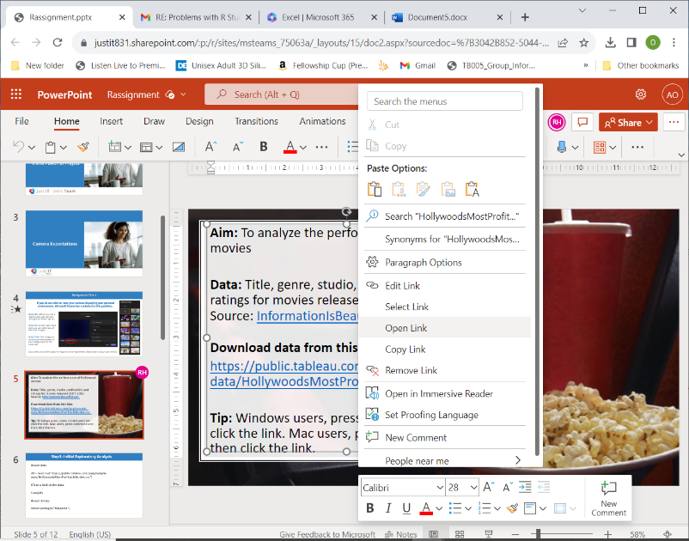

I went to the 5th slide of the PowerPoint Presentation and clicked on the “(Open Link Tab”).

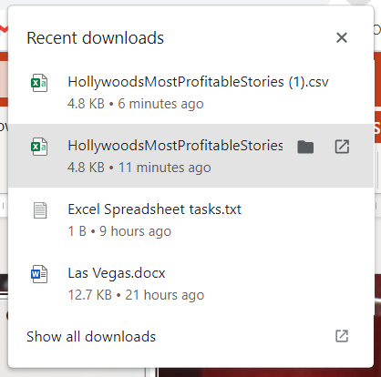

HollywoodMostProfitable Stories Excel file appeared in the downloads file and I downloaded this document.

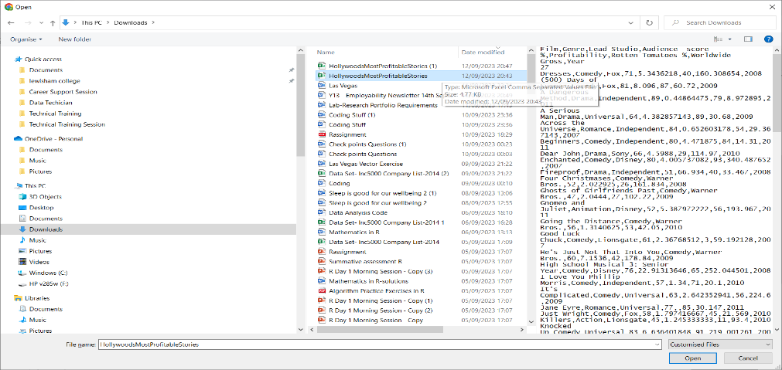

I went into Excel Microsoft 365 online and pressed on the upload button.

I also uploaded the HollywoodMostProfitable Stories Excel file and opened it automatically.

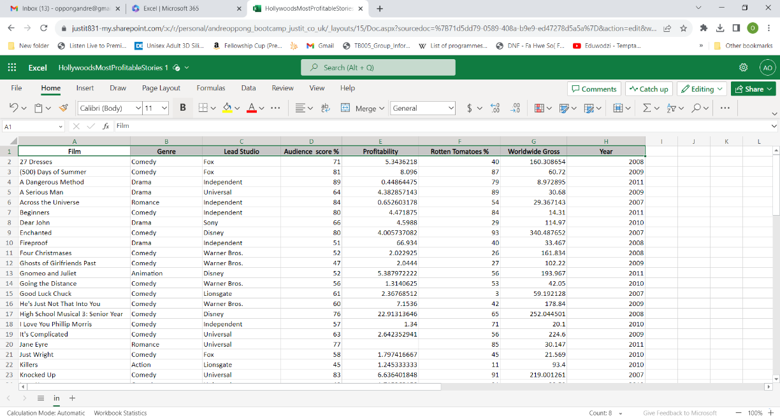

In the Excel Spreadsheet, I highlighted all the columns and made all the titles bold.

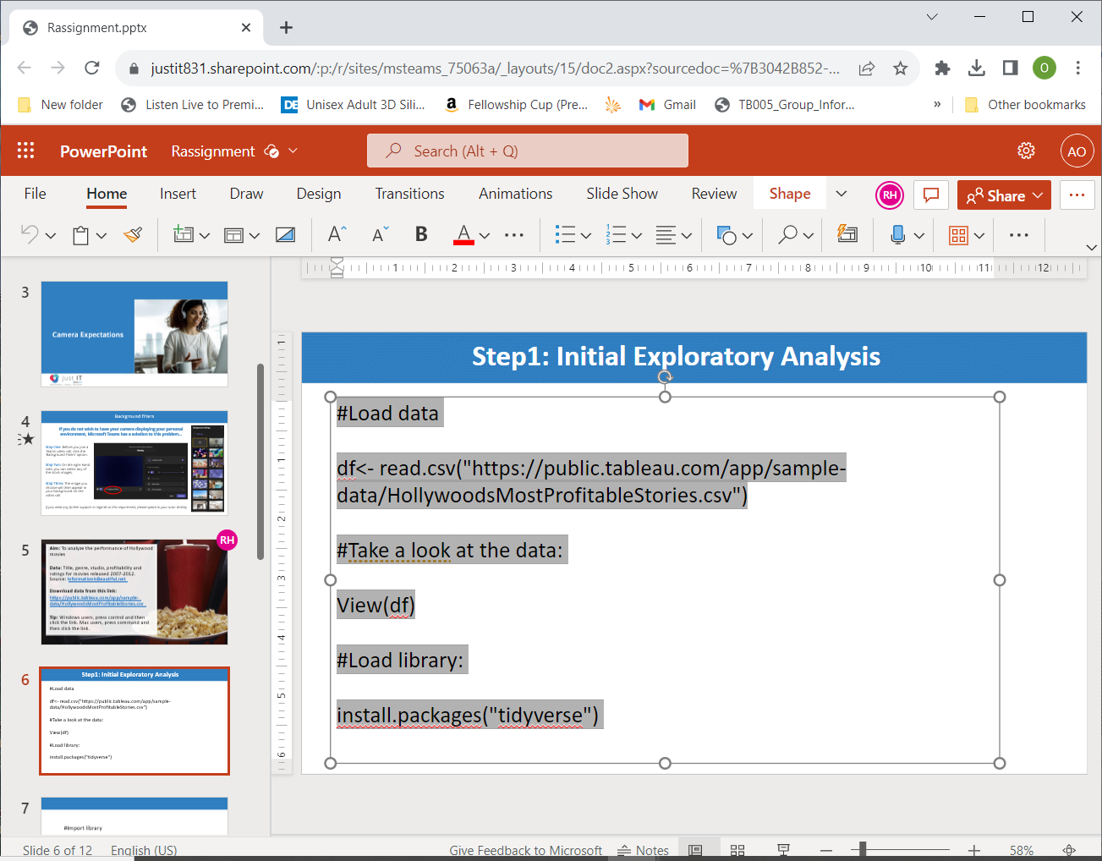

I copied and pasted the first codes from (“#Load data”) to install.packages(“tidyverse”), and transferred all the codes into the R Studio.

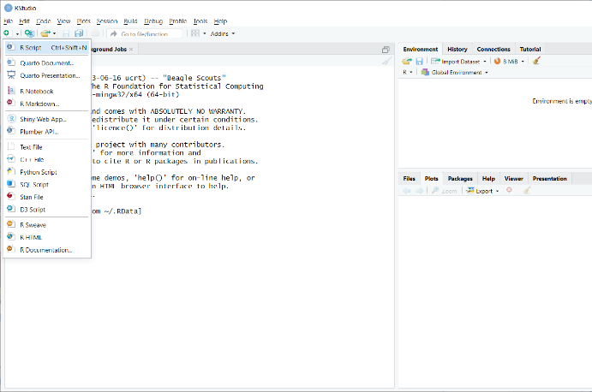

I clicked on the file in R Studios and opened the new Scripts Document.

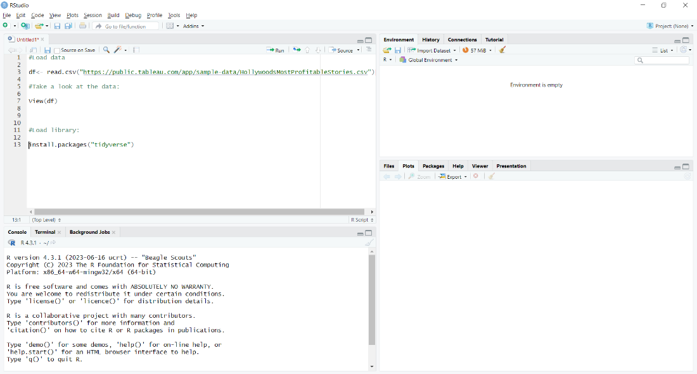

I pasted the first batch of my codes into the R Scripts.

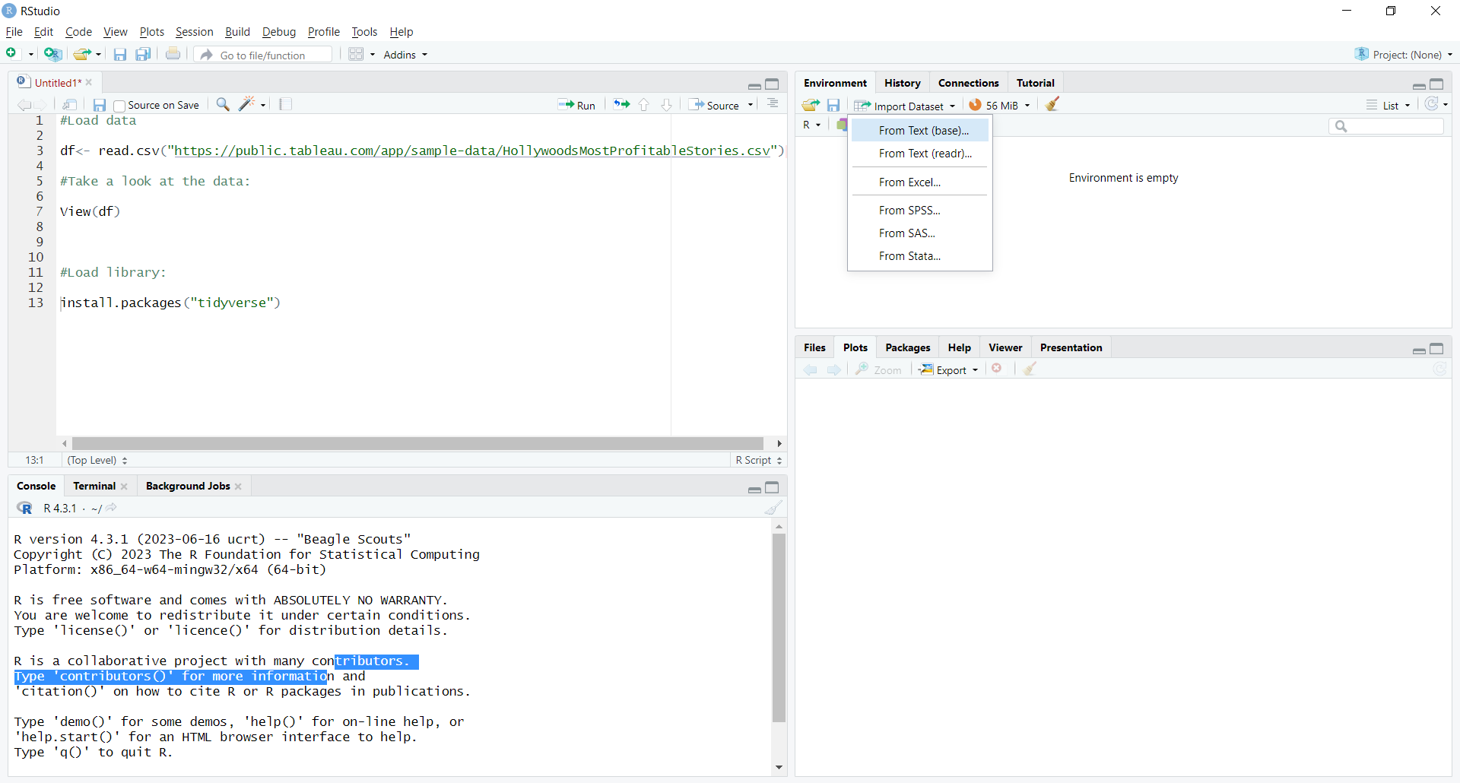

The Import Dataset enabled me to click on the **“From Text (base)”** tab to import the Hollywood Most Stories Excel file into the R Studios document.

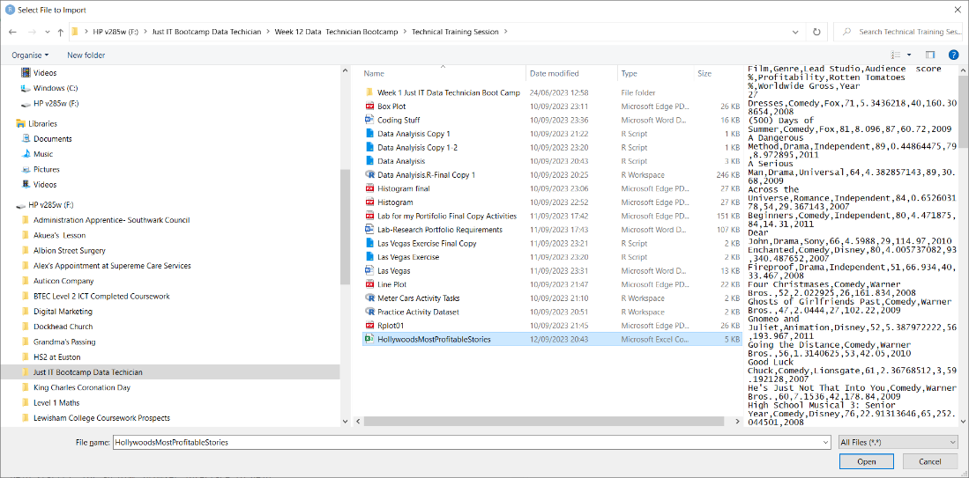

I highlighted the Hollywood Most Stories Excel File in blue to open it.

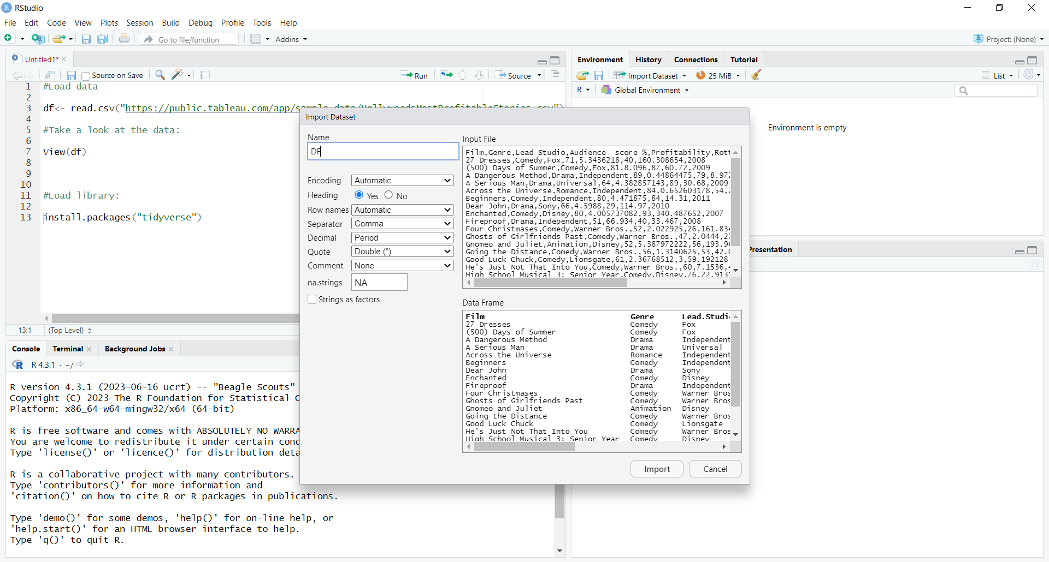

I imported the Dataset for the Hollywood Most Stories Dataset in Excel and changed the name from film to DF.

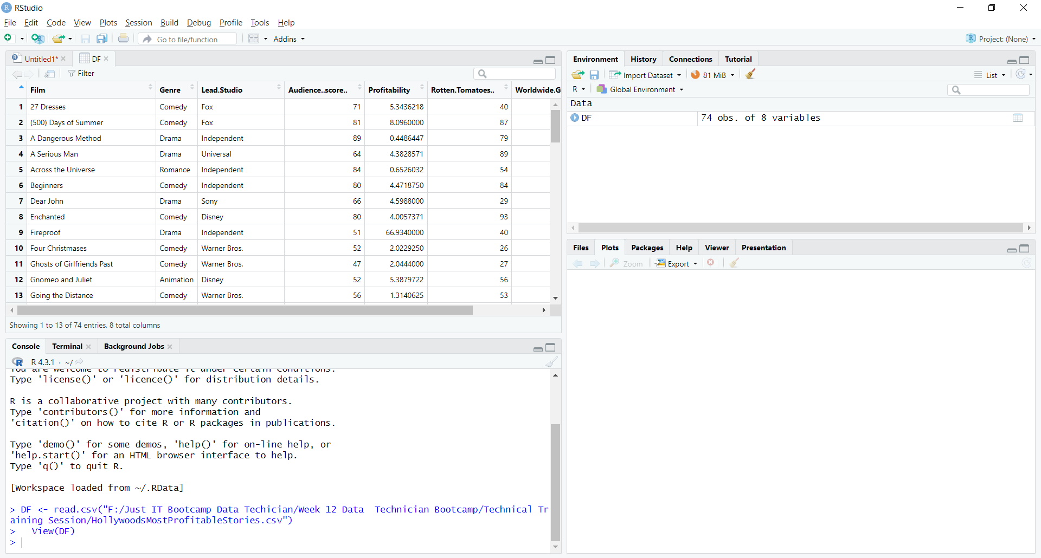

The results appeared on the Global Environment, after I cleaned the Datasets from Excel File.

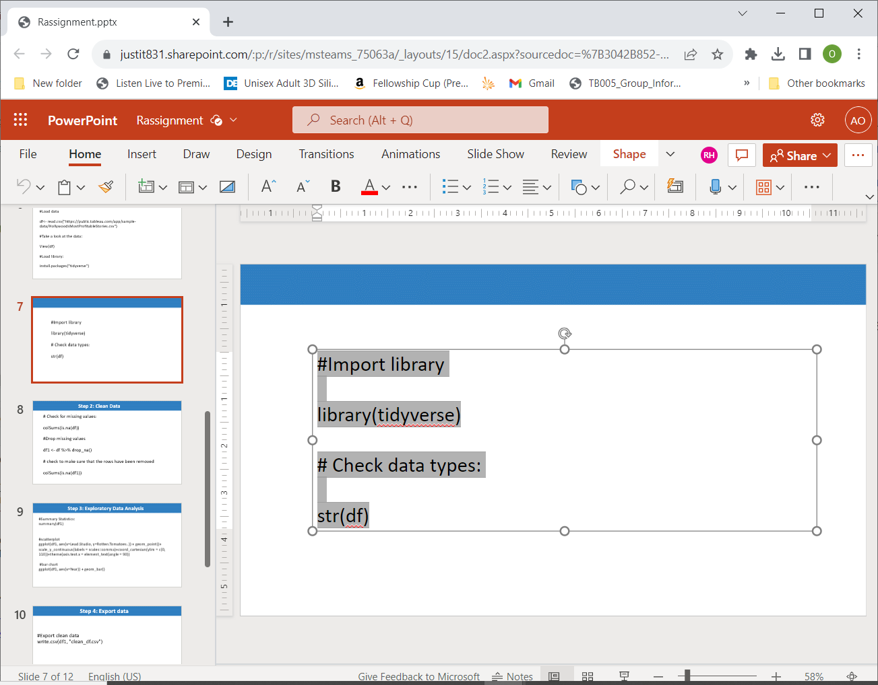

Heres’ my second batch of codes for importing datasets.

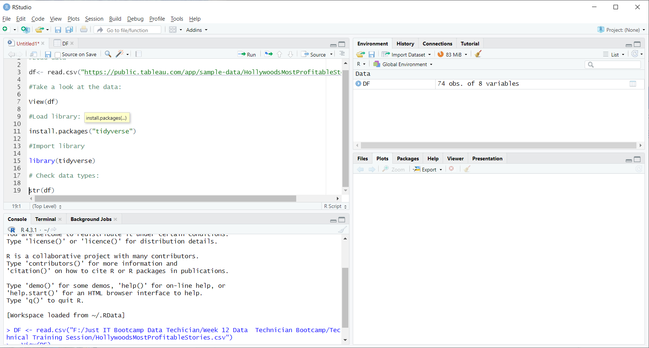

I figured out how to copy and paste the second batch of my codes into the R Scripts document.

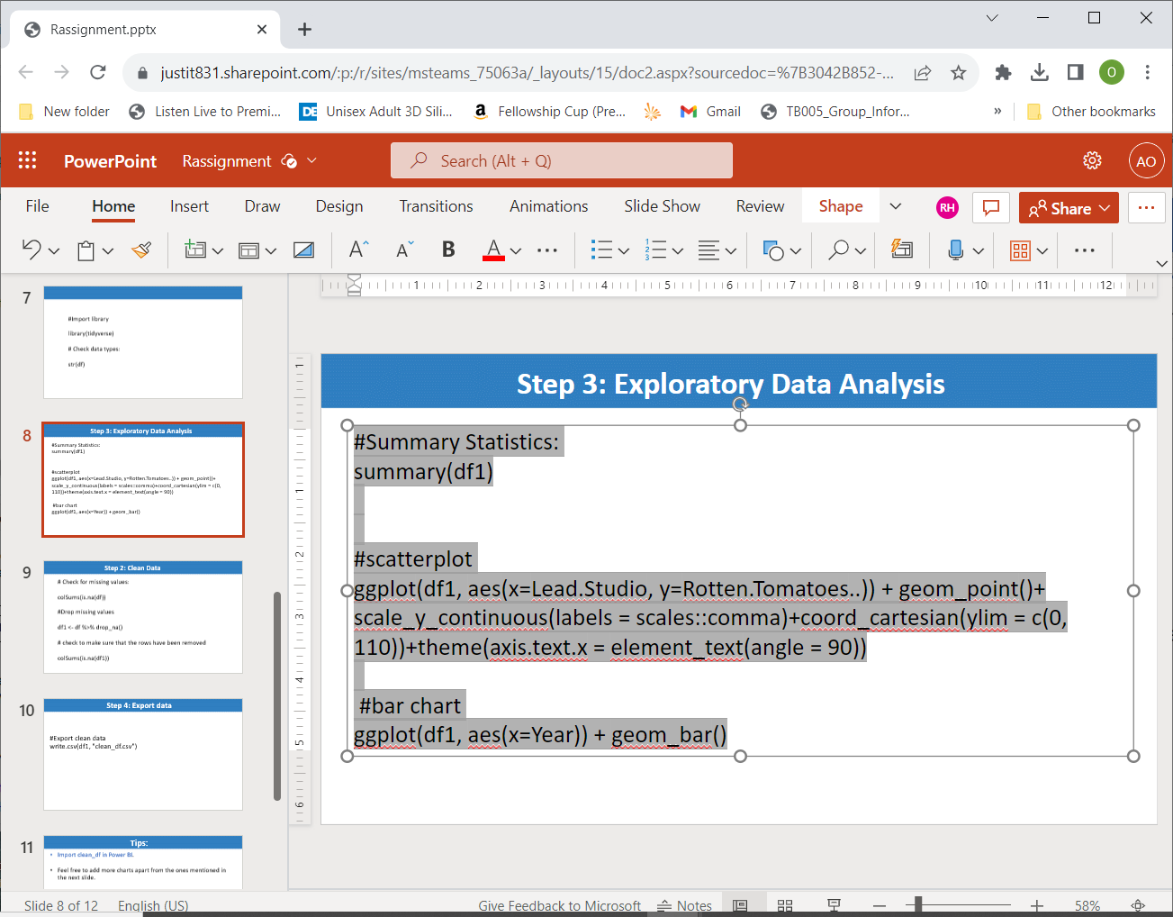

This is my third batch of codes, I am pasting it into R Studio Scripts for the time being. I highlighted those codes in grey and black to copy and paste them into the R Scripts.

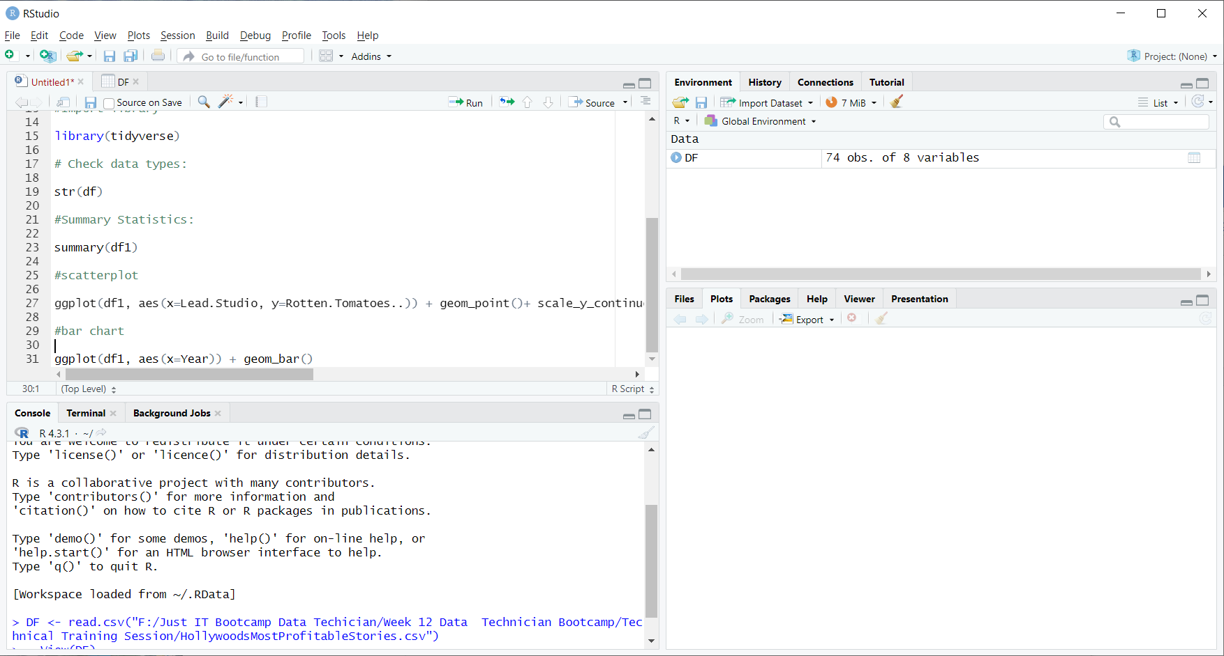This is my third batch of codes and I copied and pasted those codes into the R Scripts Document.

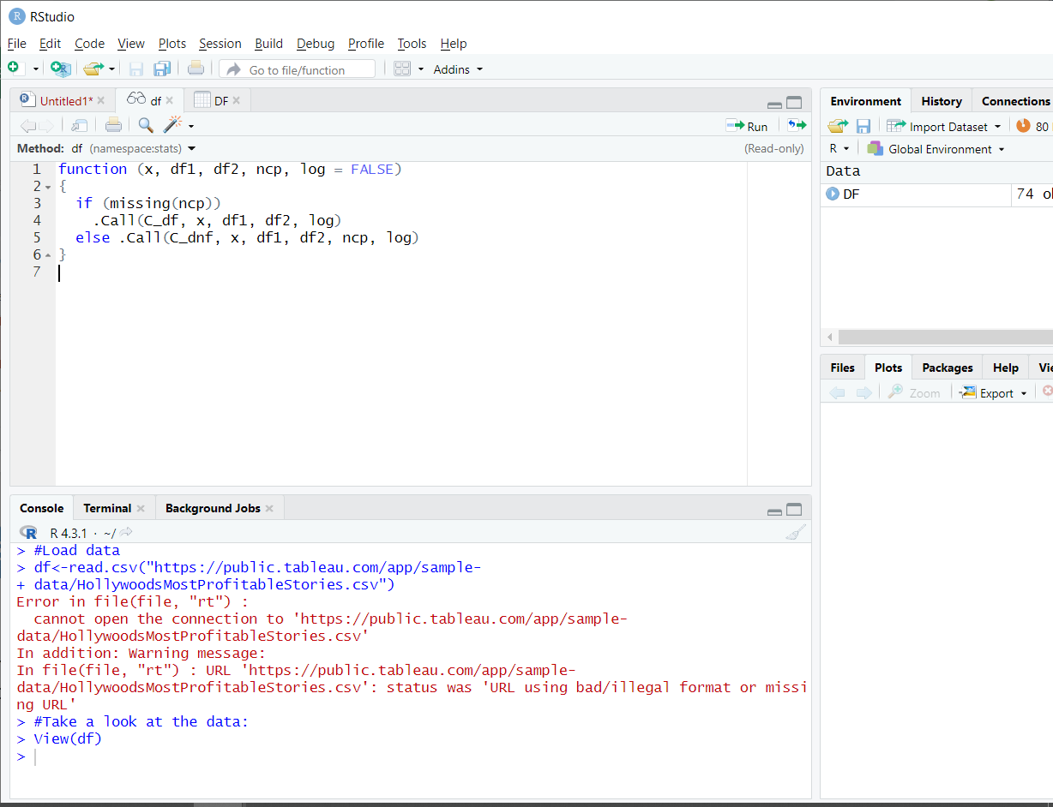

I highlighted the “#take a look at data and view(df)” codes all the functions including “df1, df2l ncp, log= FALSE”) appeared in the different tabs.

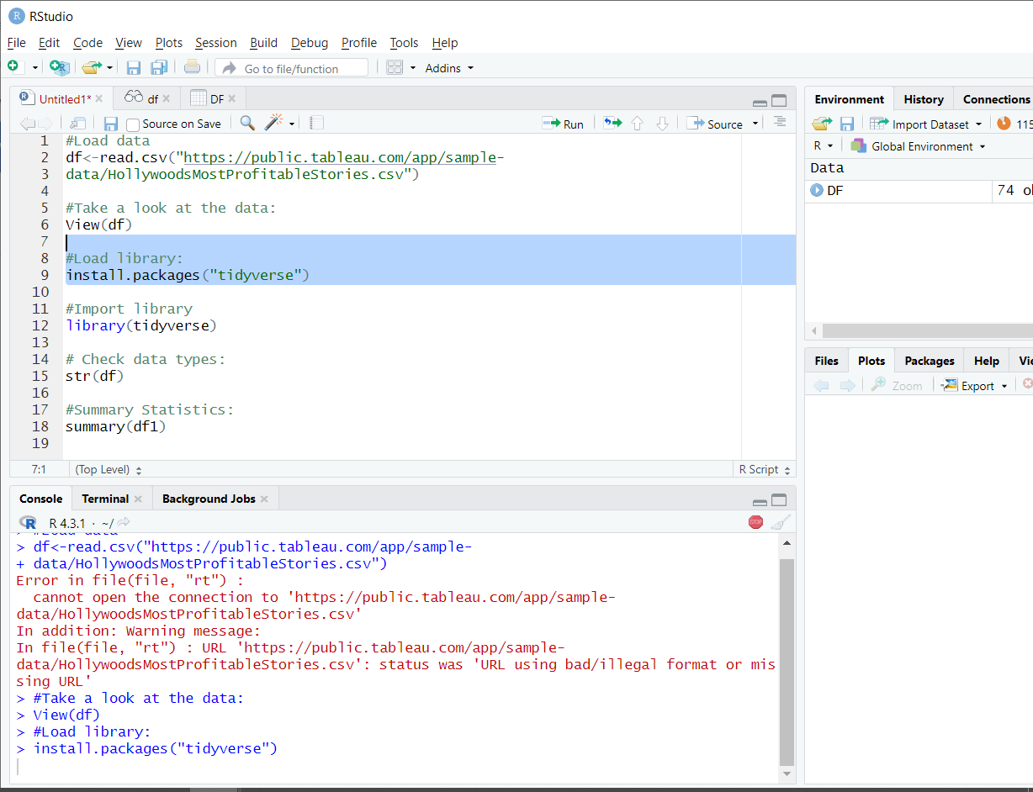

I ran the “#Load library and install.packages”(“tidyverse”) codes and pressed on the ran button to do it.

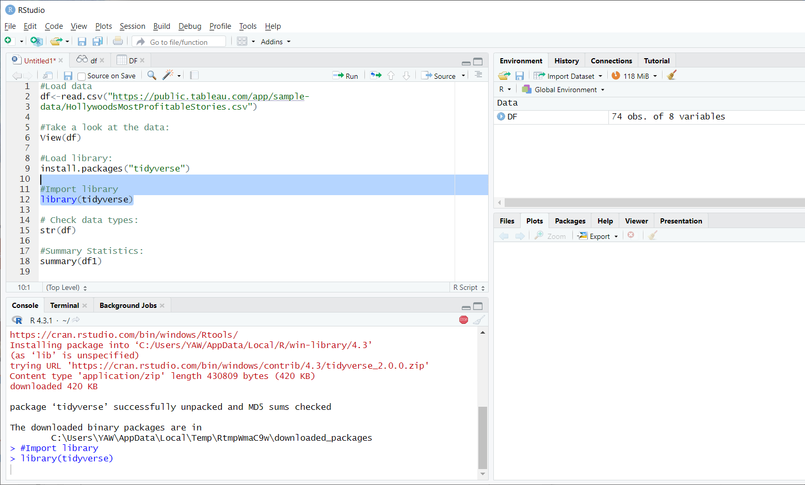

I managed to run the library (tidyverse) code and all the results appeared.

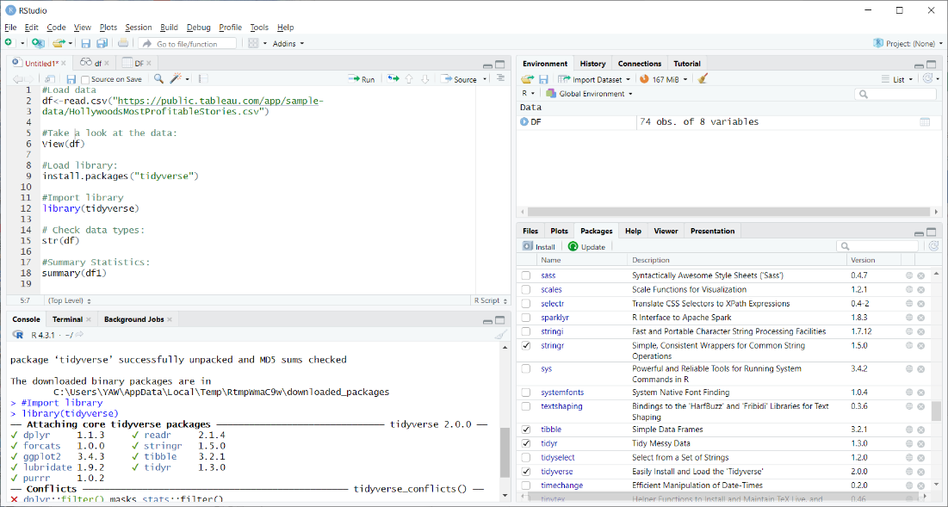

Tidyverse packages results came out correctly and the statistics showed, there were forcats 1.0.0, tidyr 1.3.0, tibble 3.2.1 and ggplot2 3.4.3.

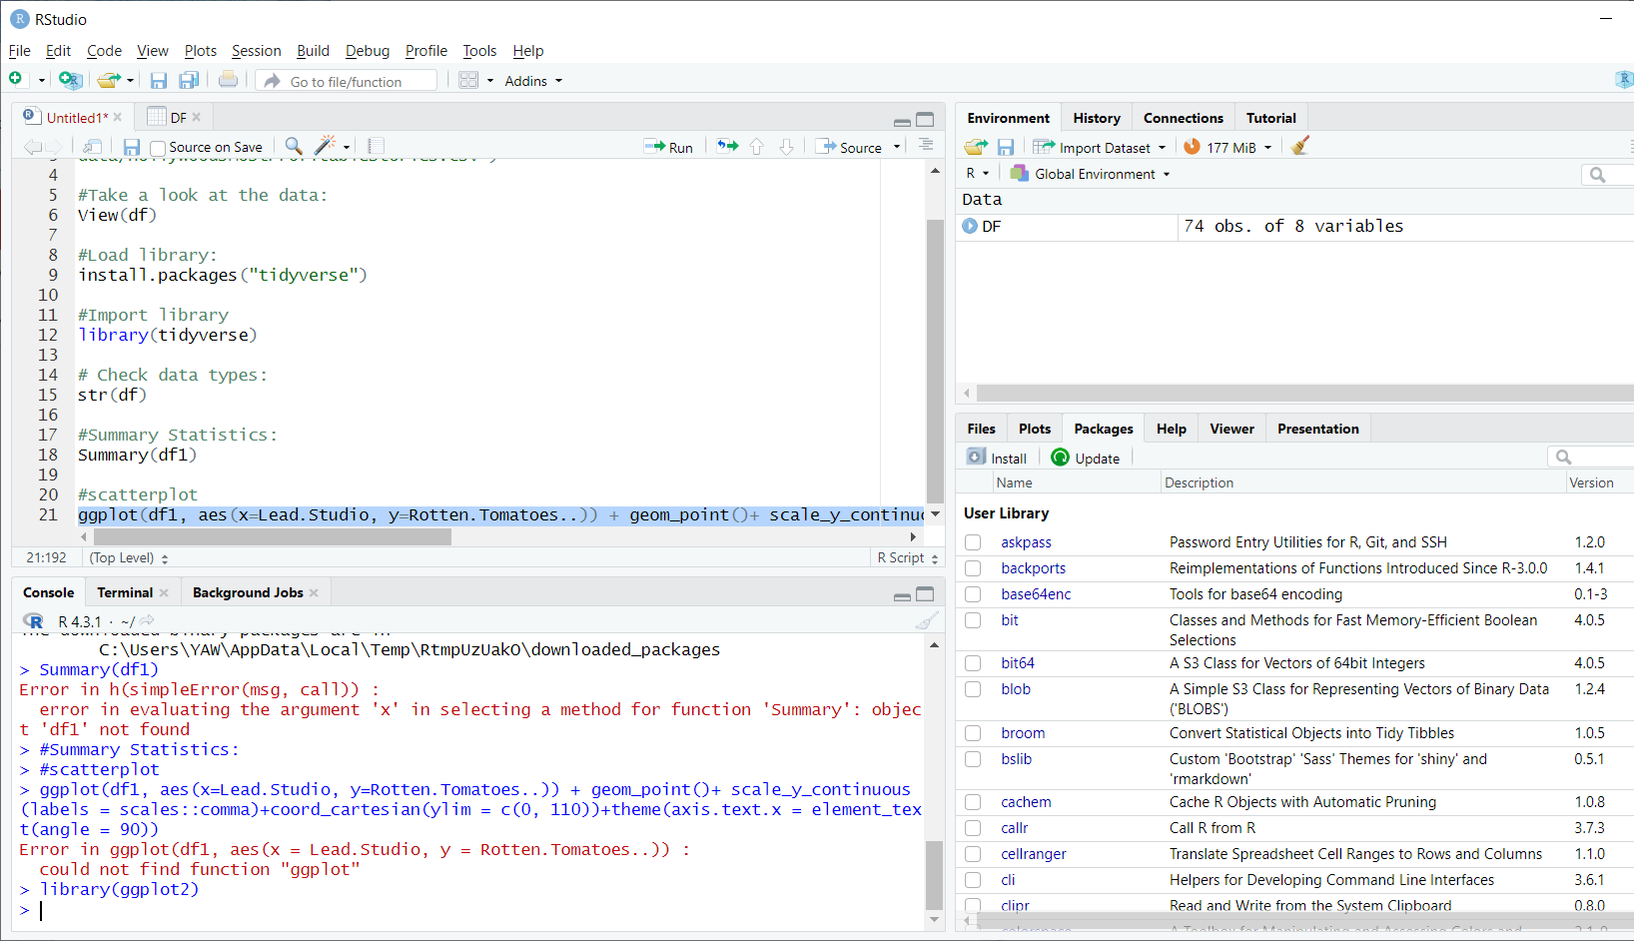

Binary Packages results appeared automatically with (“C:/Users/YAW/AppData/Local/Temp/RtmpUzUakO/downloaded packages”).

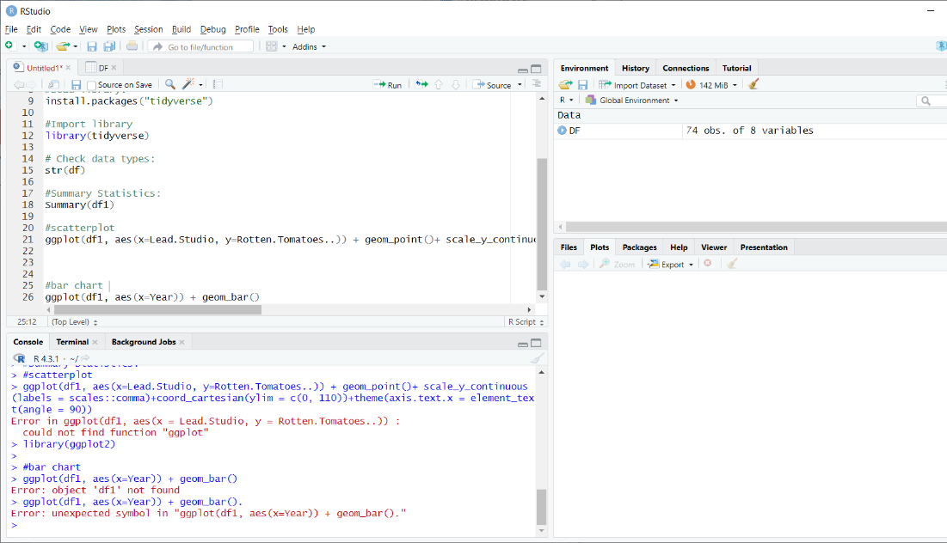

I pasted the “(# scatterplot and #bar chart”) codes into the R Scripts and Console documents as well.

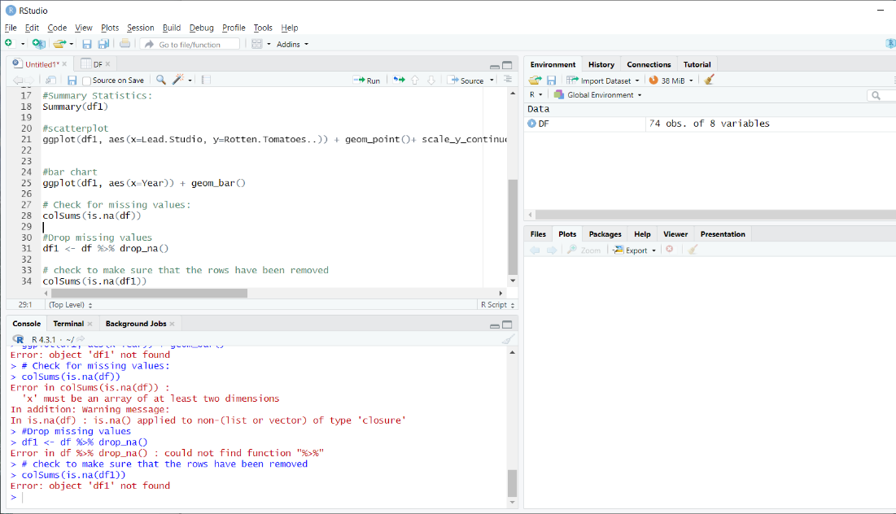

I pasted all the codes into the R Scripts documents from (“#bar chart to colSums(is.na(df1))”.

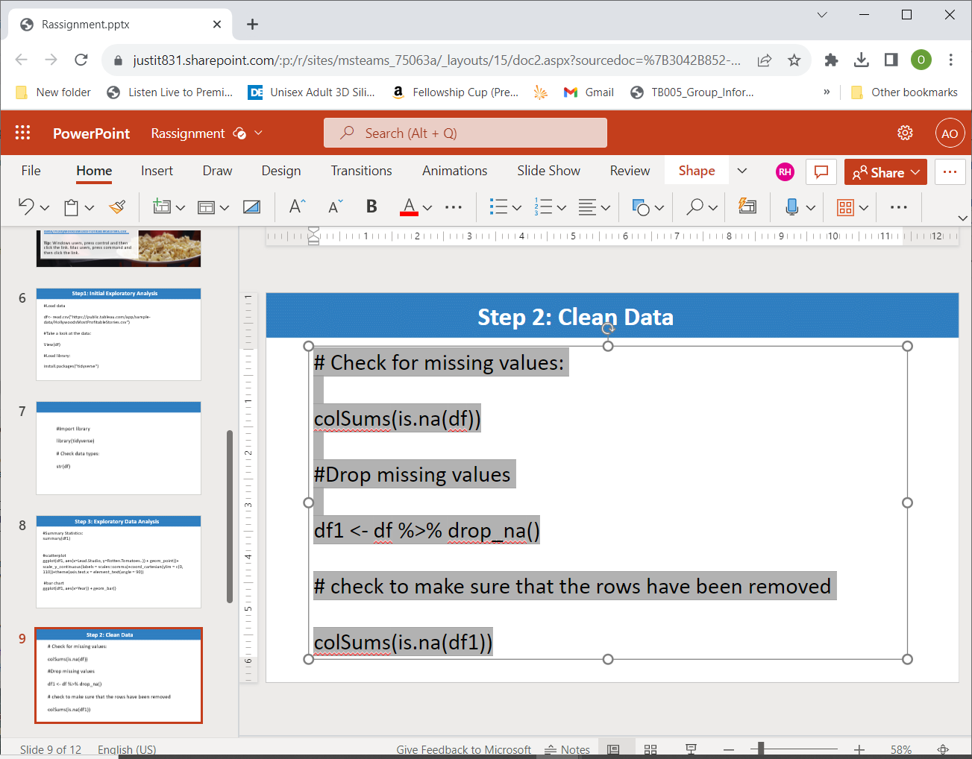

I copied and pasted the fourth batch of the codes into the R Scripts documents for importing, manipulating and cleaning Datasets.

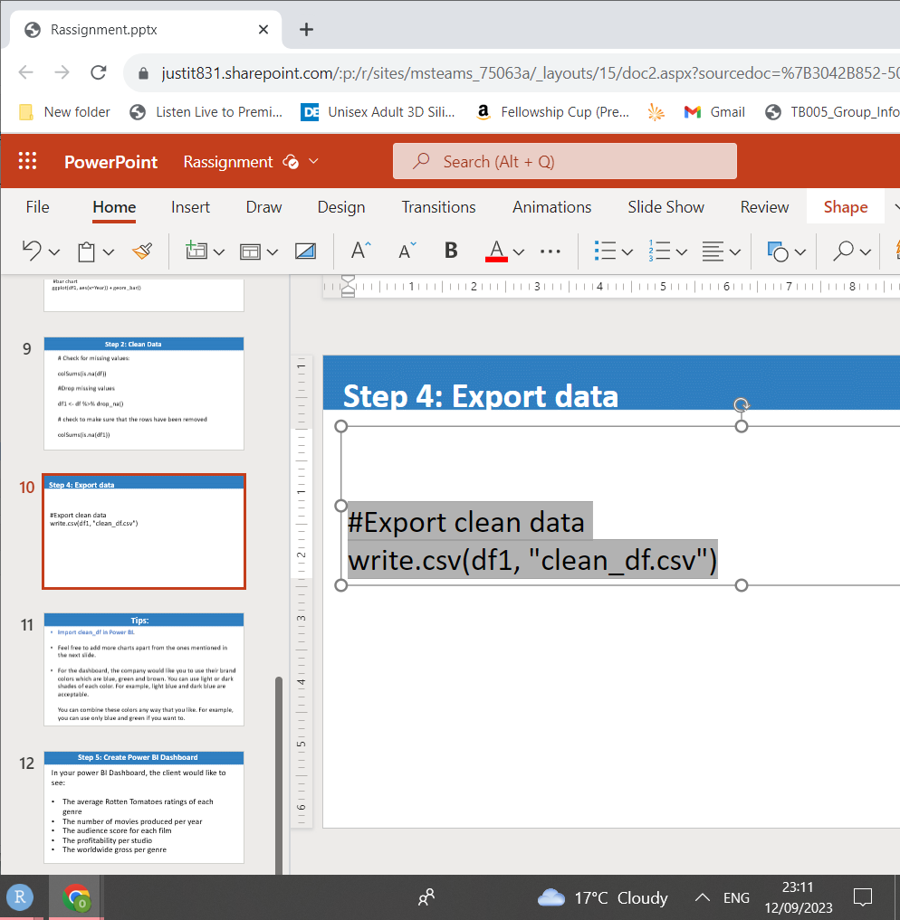

This is my final batches of codes in the Export Data section and highlighted these codes in Power Point.

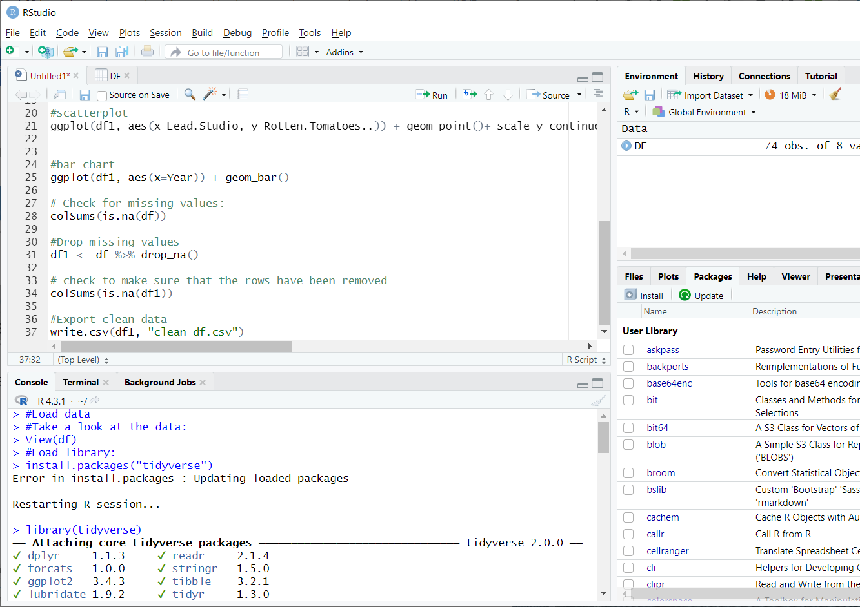

I copied and pasted my final batch of codes into the R Scripts Document successfully.

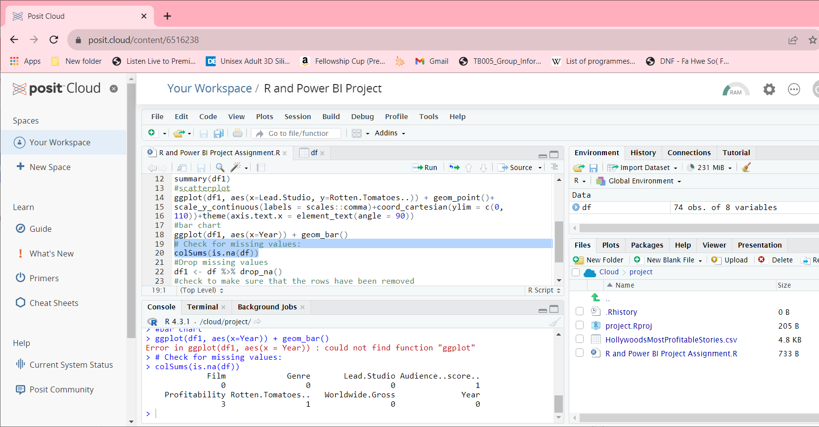

In this image, I used my cursor and highlighted the two codes in to run them.

The results for the “colSums is.na (df))” codes showed up in the Console Section.

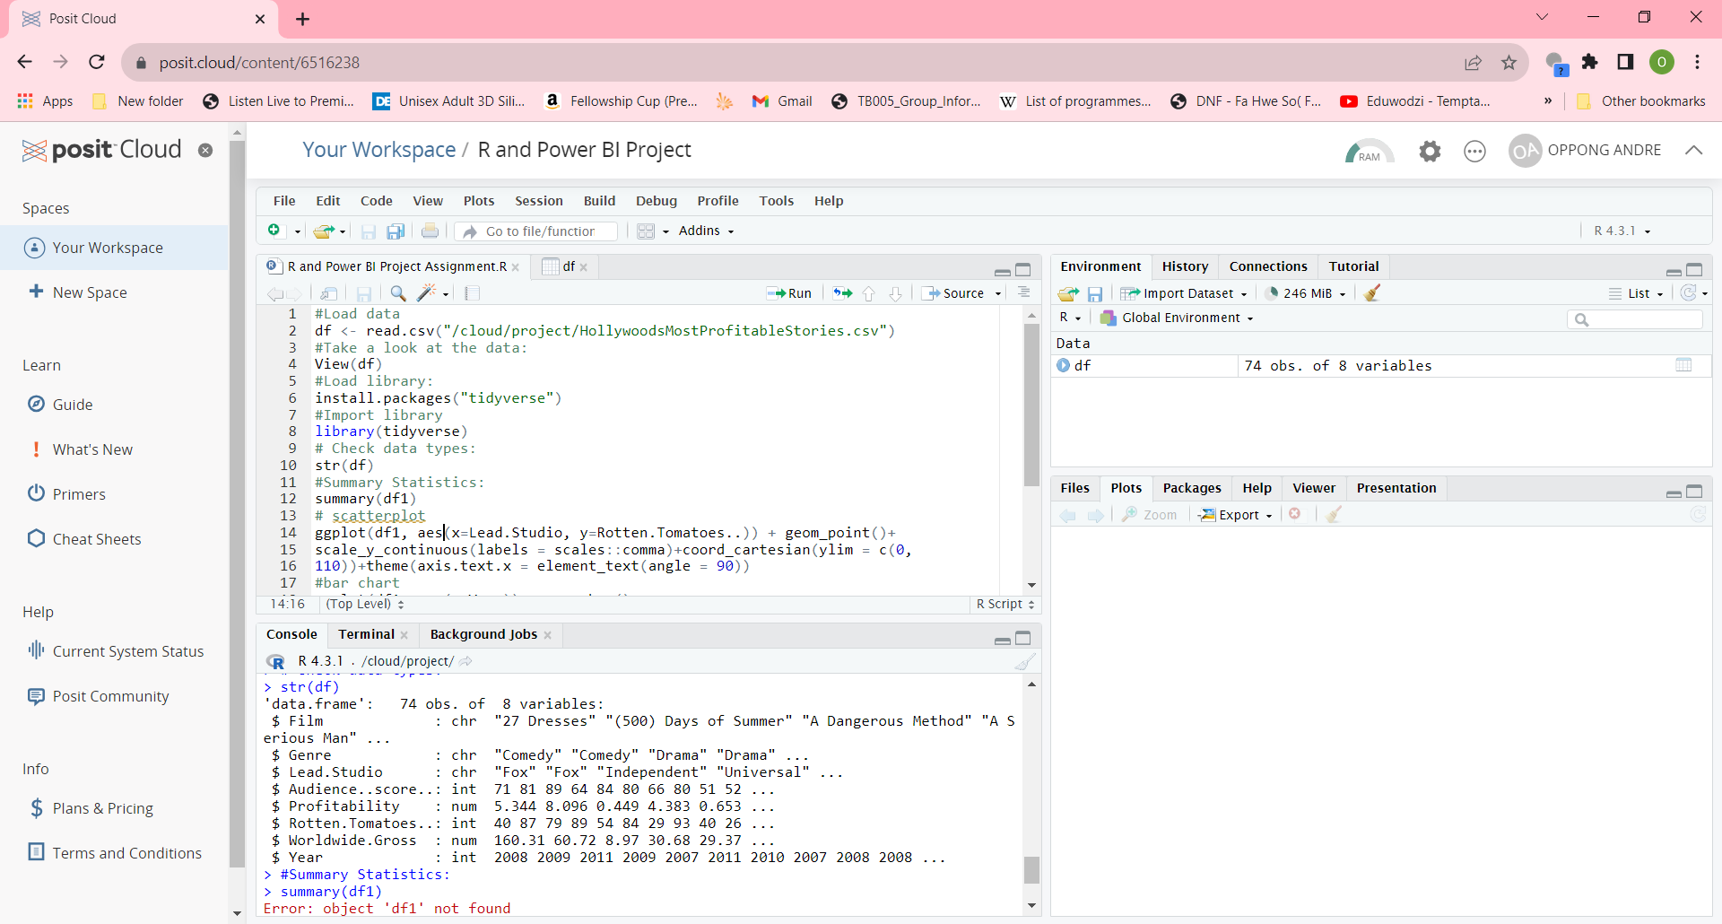

The results for the Data Types came out correctly, after I highlighted the “check data types” and “str(df)” codes to run them.

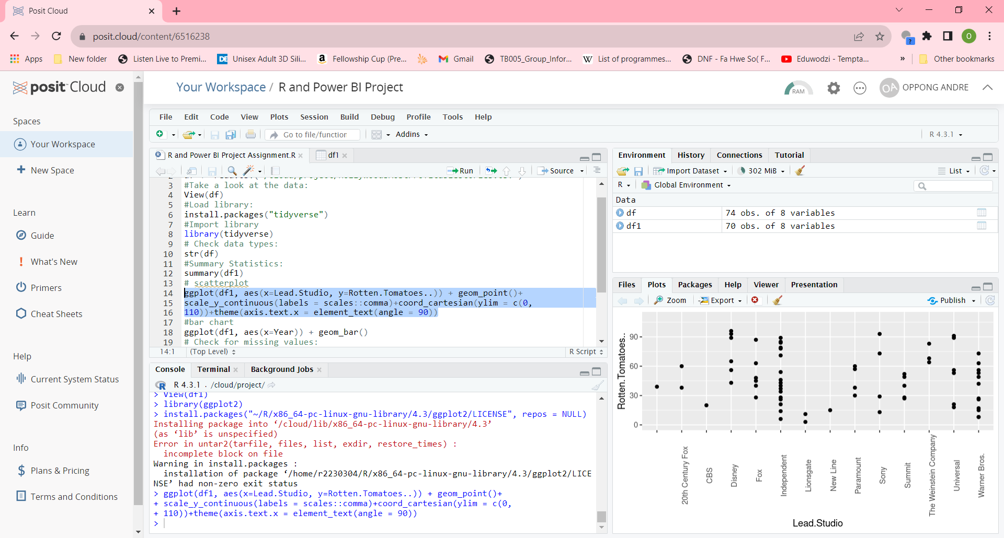

The Scatterplot chart showed, there were 89% and 61% profits for the fox studio and 90% profits for the Independent Studio.

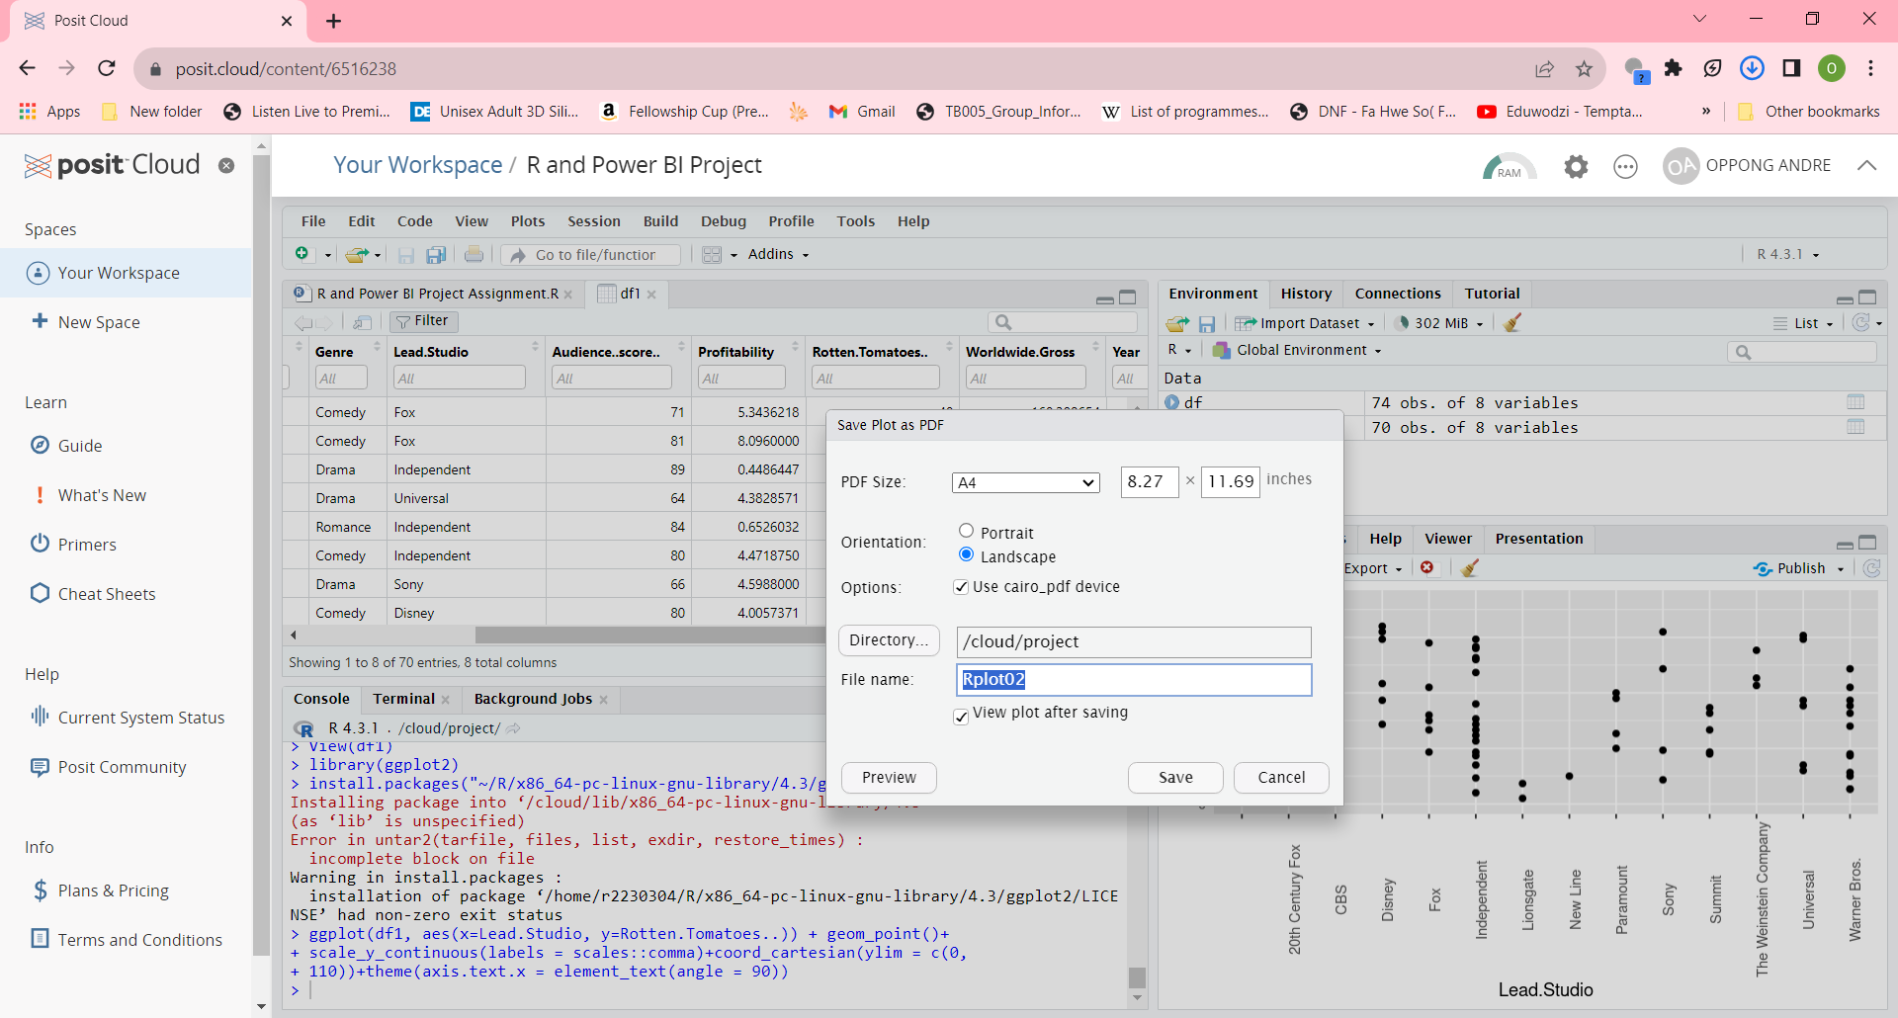

I downloaded the Scatterplot Chart in PDF version and saved it in documents.

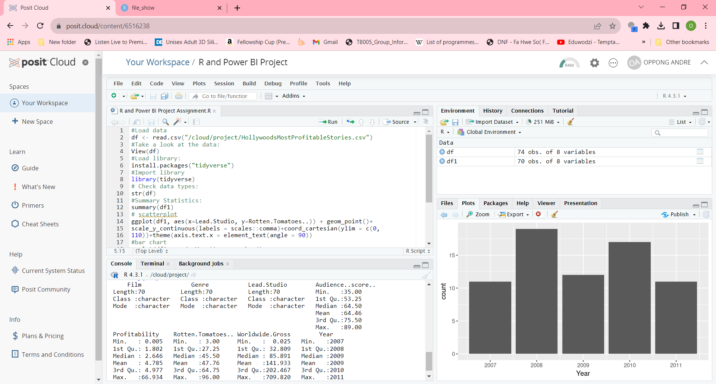

I pressed on the run button for “# Summary Statistics” code and all the results for the Audience Score, Profitability, Rotten. Tomatoes and Worldwide Gross including Year for the film appeared in the console section.

Audience Score is min 35.00, 1st quarter 53.25, median 64.50, mean 64.46, 3rd quarter 75.50 and max 89.00.

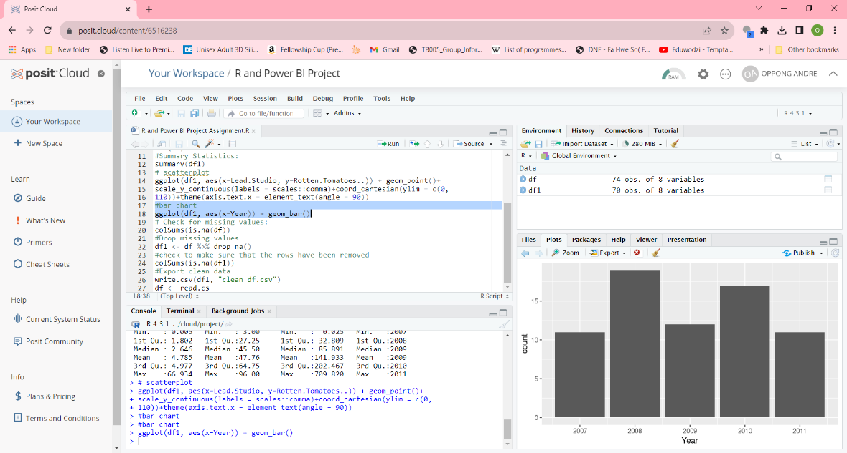

I ran the “ggplot(df+1, aes(x Year)) +geom_bar() for the Bar Chart and Scatterplot codes in R Studios Scripts.   
I pressed the run button and the Bar Chart for the Year showed up in the Plots section automatically.

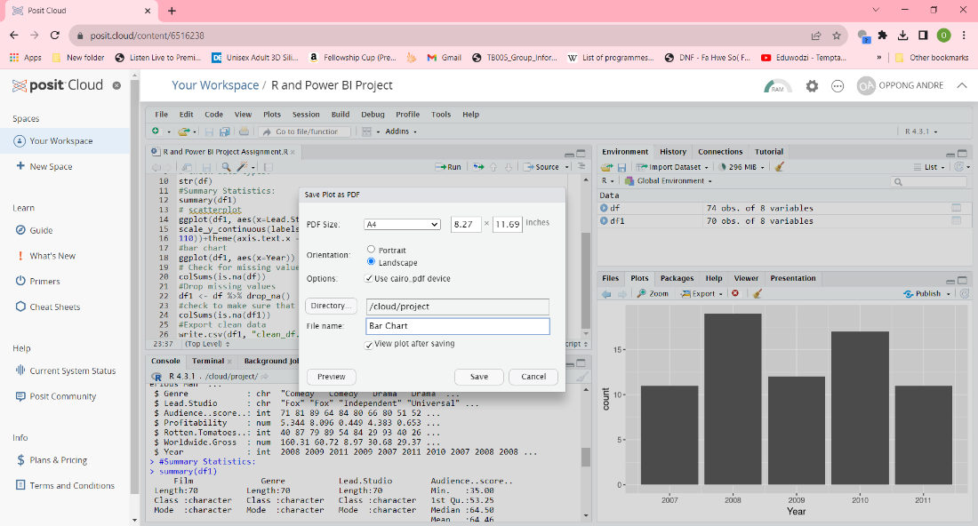

I clicked on the Import button and renamed the file Bar Chart.

|  |
| --- |
| #Load data > df <- read.csv("/cloud/project/HollywoodsMostProfitableStories.csv") > #Take a look at the data:  > View(df) > #Load library: > install.packages("tidyverse")  Error in install.packages : Updating loaded packages  Restarting R session...  > install.packages("tidyverse") Installing package into ‘/cloud/lib/x86_64-pc-linux-gnu-library/4.3’ (as ‘lib’ is unspecified) trying URL '<http://rspm/default/__linux__/focal/latest/src/contrib/tidyverse_2.0.0.tar.gz>' Content type 'application/x-gzip' length 425237 bytes (415 KB) ================================================== downloaded 415 KB  * installing *binary* package ‘tidyverse’ ... * DONE (tidyverse)  The downloaded source packages are in  ‘/tmp/Rtmp25d1F1/downloaded_packages’ > #Import library  > library(tidyverse) ── **Attaching core tidyverse packages** ───────────────────────────── tidyverse 2.0.0 ── ✔ dplyr 1.1.3 ✔ readr 2.1.4 ✔ forcats 1.0.0 ✔ stringr 1.5.0 ✔ ggplot2 3.4.3 ✔ tibble 3.2.1 ✔ lubridate 1.9.2 ✔ tidyr 1.3.0 ✔ purrr 1.0.2  ── **Conflicts** ─────────────────────────────────────────────── tidyverse_conflicts() ── ✖ dplyr::filter() masks stats::filter() ✖ dplyr::lag() masks stats::lag() ℹ Use the conflicted package to force all conflicts to become errors > # Check data types:  > str(df) 'data. Frame': 74 obs. of 8 variables:  $ Film : chr "27 Dresses" "(500) Days of Summer" "A Dangerous Method" "A Serious Man" ...  $ Genre : chr "Comedy" "Comedy" "Drama" "Drama" ...  $ Lead.Studio : chr "Fox" "Fox" "Independent" "Universal" ...  $ Audience..score..: int 71 81 89 64 84 80 66 80 51 52 ...  $ Profitability : num 5.344 8.096 0.449 4.383 0.653 ...  $ Rotten.Tomatoes..: int 40 87 79 89 54 84 29 93 40 26 ...  $ Worldwide.Gross : num 160.31 60.72 8.97 30.68 29.37 ...  $ Year : int 2008 2009 2011 2009 2007 2011 2010 2007 2008 2008 ... > #Summary Statistics:  > summary(df1)  Film Genre Lead.Studio Audience..score..  Length:70 Length:70 Length:70 Min. :35.00   Class :character Class :character Class :character 1st Qu.:53.25   Mode :character Mode :character Mode :character Median :64.50   Mean :64.46   3rd Qu.:75.50   Max. :89.00   Profitability Rotten.Tomatoes.. Worldwide.Gross Year   Min. : 0.005 Min. : 3.00 Min. : 0.025 Min. :2007   1st Qu.: 1.802 1st Qu.:27.25 1st Qu.: 32.809 1st Qu.:2008   Median : 2.646 Median :45.50 Median : 85.891 Median :2009   Mean : 4.785 Mean :47.76 Mean :141.933 Mean :2009   3rd Qu.: 4.977 3rd Qu.:64.75 3rd Qu.:202.467 3rd Qu.:2010   Max. :66.934 Max. :96.00 Max. :709.820 Max. :2011  > # scatterplot  > ggplot(df1, aes(x=Lead.Studio, y=Rotten.Tomatoes..)) + geom_point()+ + scale_y_continuous(labels = scales::comma)+coord_cartesian(ylim = c(0, + 110))+theme(axis.text.x = element_text(angle = 90)) > #bar chart > #bar chart > ggplot(df1, aes(x=Year)) + geom_bar() > # Check for missing values: > colSums(is.na(df))  Film Genre Lead.Studio Audience..score..   0 0 0 1   Profitability Rotten.Tomatoes.. Worldwide.Gross Year   3 1 0 0  > #Drop missing values > df1 <- df %>% drop_na() > #check to make sure that the rows have been removed > colSums(is.na(df1))  Film Genre Lead. Studio Audience. Score..   0 0 0 0   Profitability Rotten. Tomatoes.. Worldwide. Gross Year   0 0 0 0  > #Export clean data Session restored from your saved work on 2023-Sep-13 15:09:15 UTC (13 minutes ago) |
|  |
| |  | | --- | | > | |

I pasted these codes from R Studios to Word Document. First, I highlighted and copied all the codes from the RStudio Scripts.

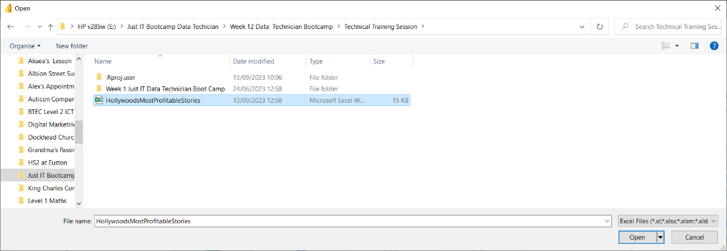

In the import Excel file tab, I used my mouse and opened the HollywoodMostProtfitable Stories Document for importing.

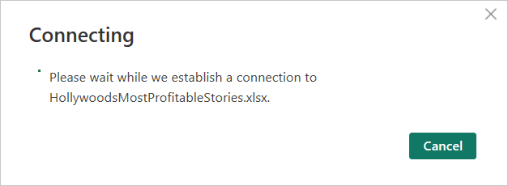

As soon as I uploaded the HollywoodMostProfitable Stories Excel file, the above message appeared on my laptop instructing me to wait patiently, whilst connecting to the Excel Document.

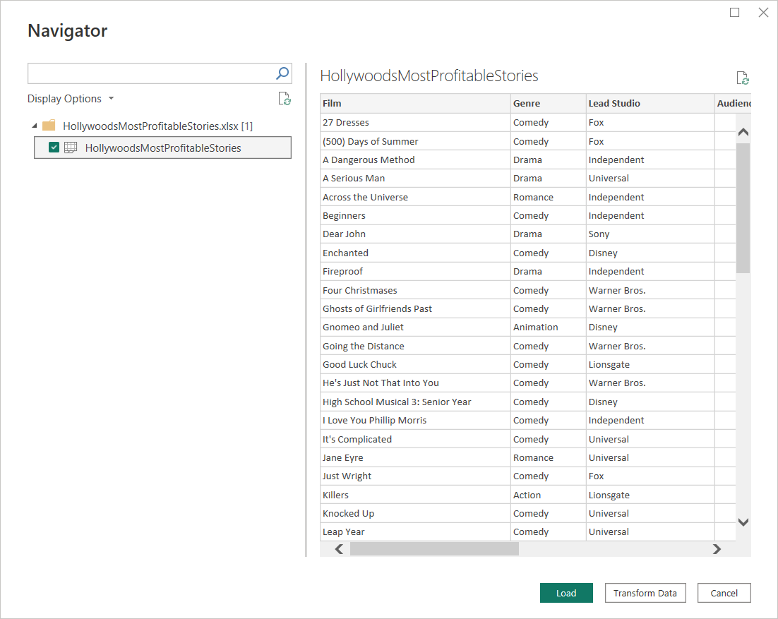

One minute later, the Navigator tab appeared in front of my screen, where I clicked on the HollywoodMostProfitableStories file in the Display Options before I uploaded the data.

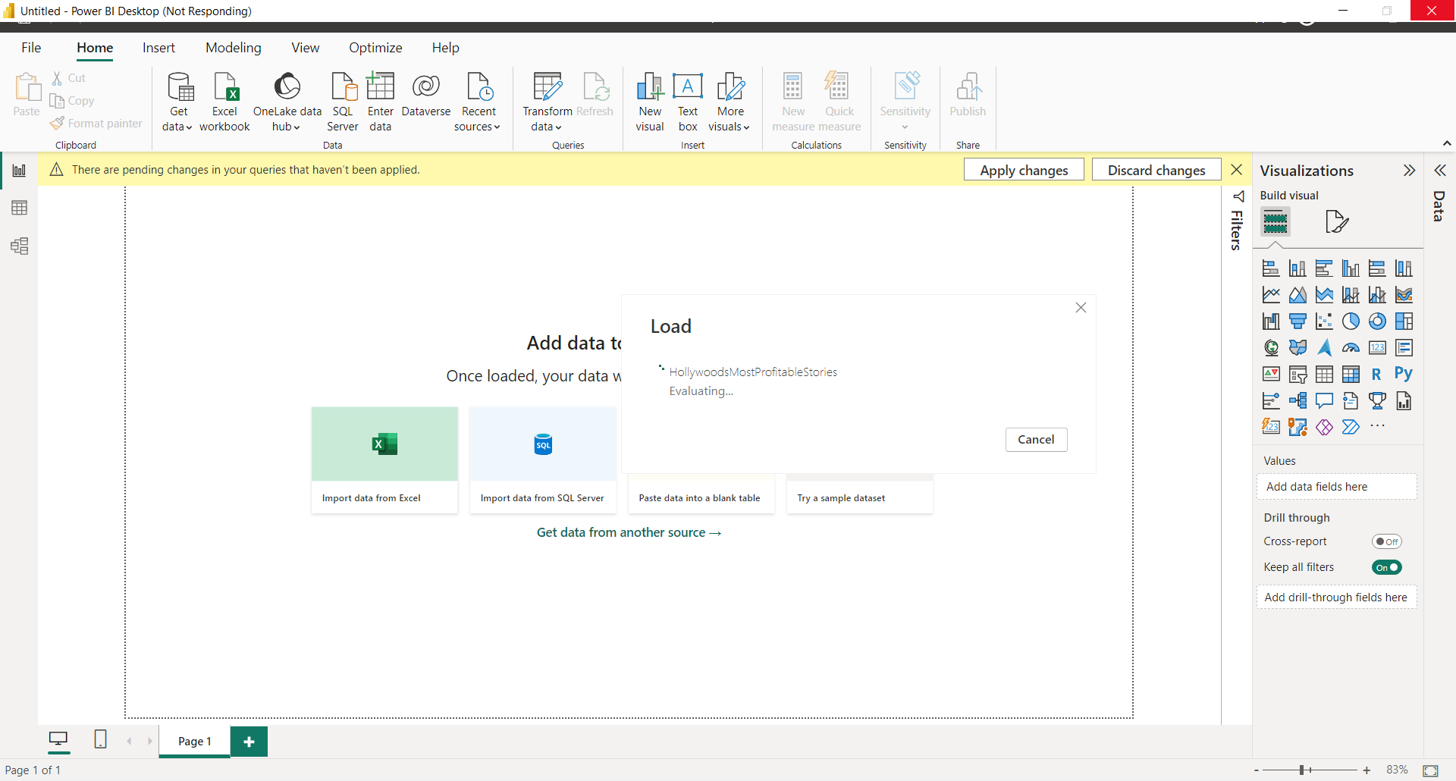

I also uploaded the HollyWoodsMostProfitableStories Excel File into the Power BI and the message appeared.

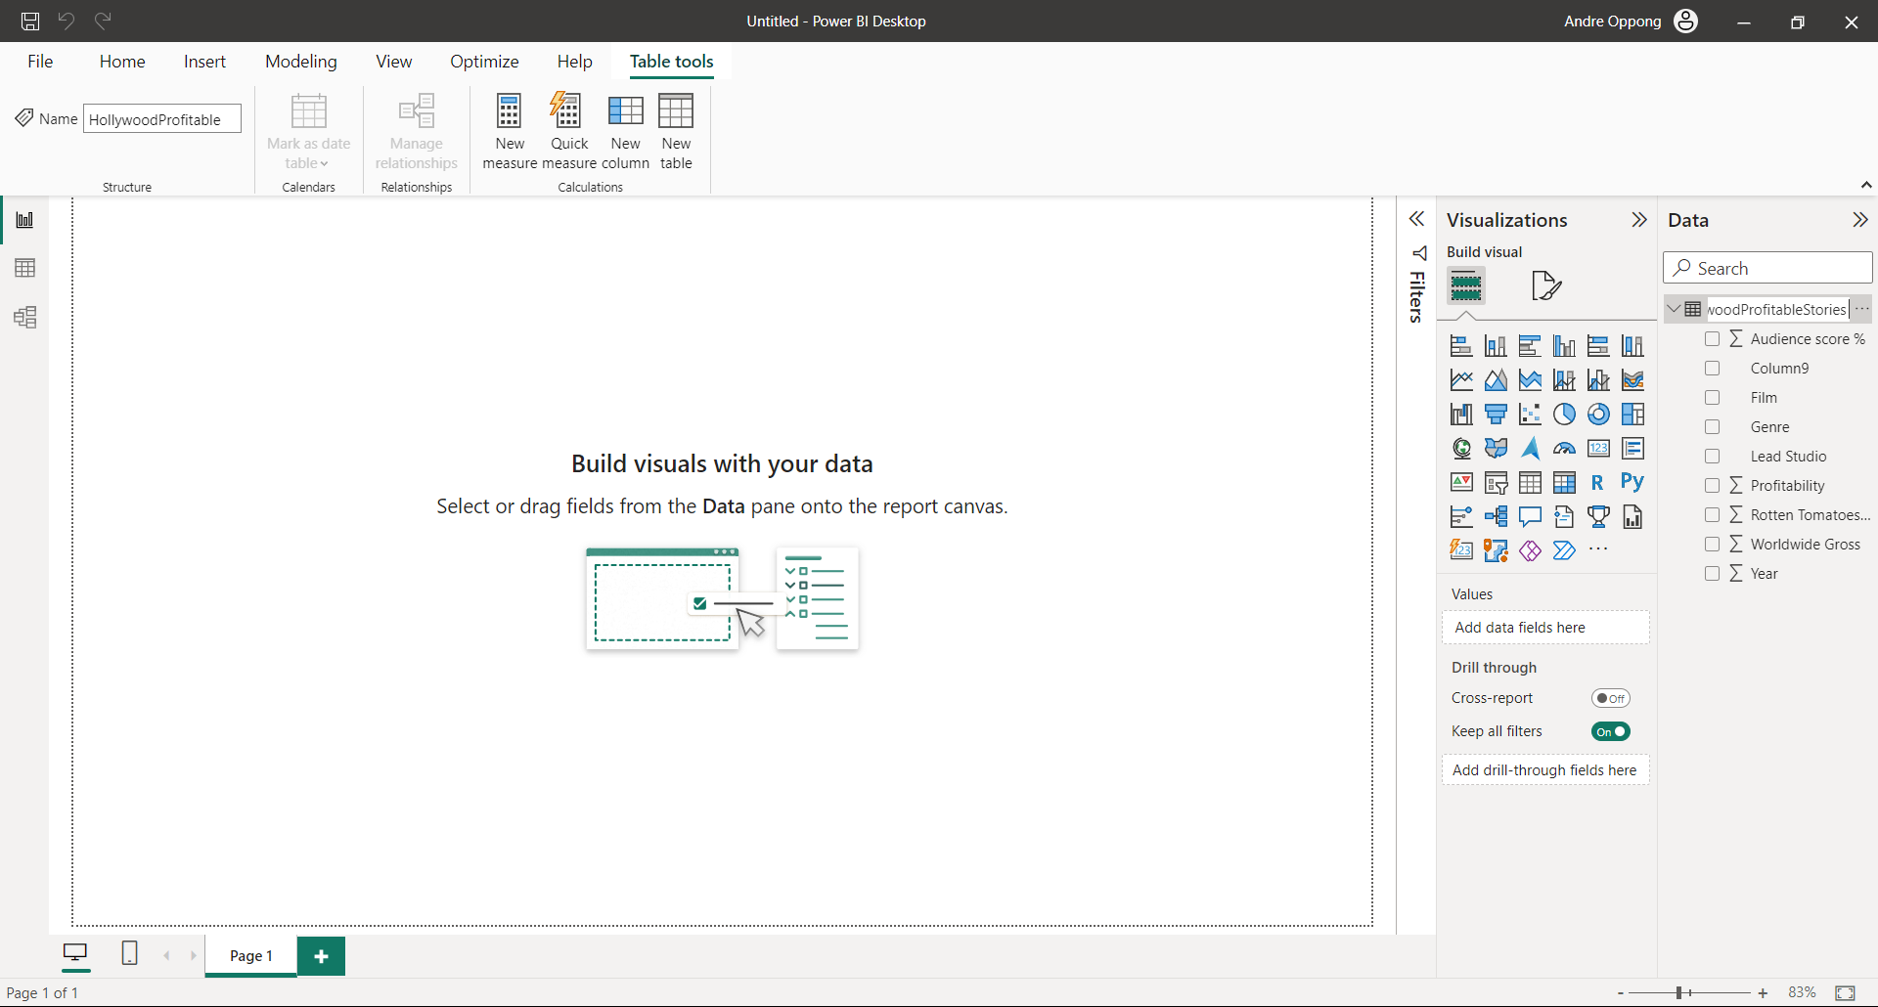

I renamed my title Hollywood Profitable Stories in the Data Search box.

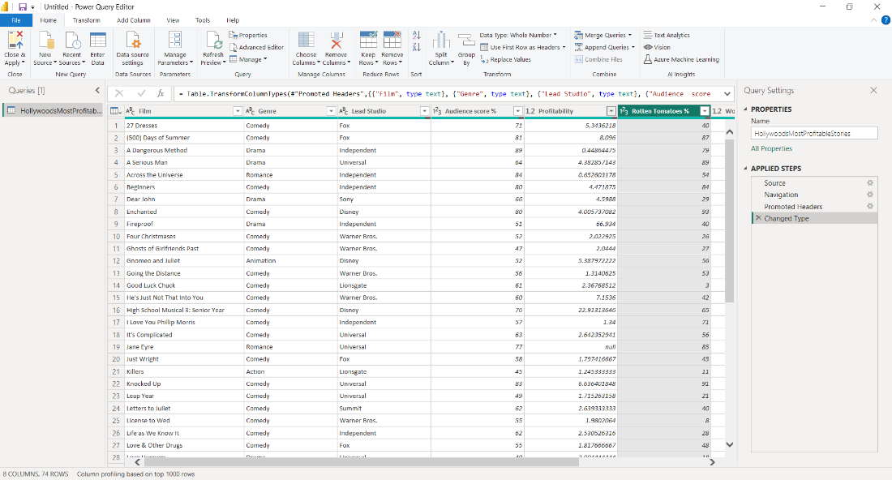

I clicked on the Transform Data in the Display Options and did data cleaning on HollywoodProfitableStories Excel File in Power BI.

All the results on the Hollywood Profitable Stories project appeared in the Power Query Editor.

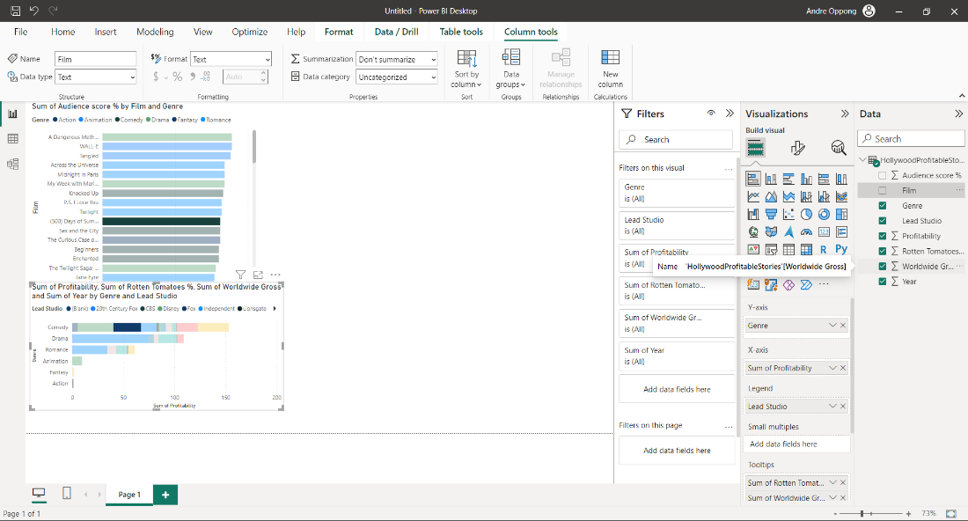

I went to the Data options and selected the Audience Score, Film, Genre, Lead Studio, Profitability, Rotten Tomatoes, Worldwide Gross and Year to create two Bar Charts.

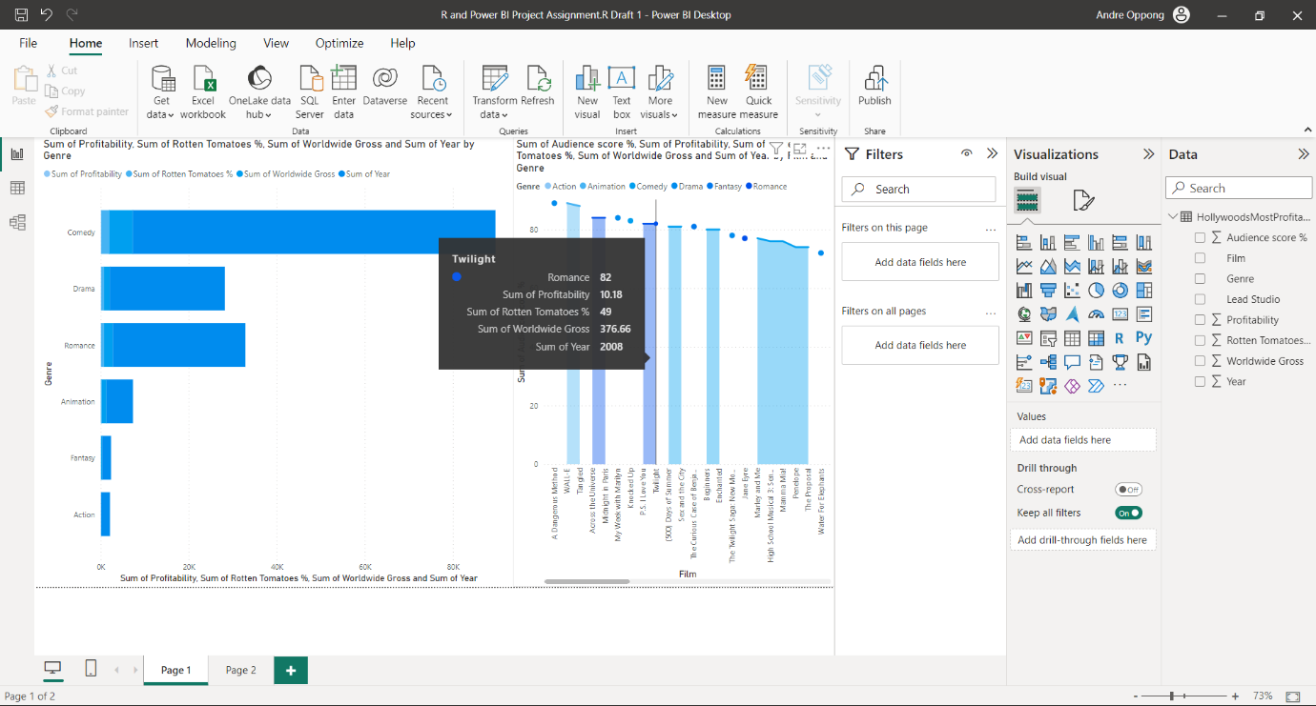I also went onto the Theme Colours options and chose the light blue and green for my Bar Charts.

I created a Scattered Area Chart on the movie and used light blue to colour it.

Twilight movie had 82 Romance on the Scattered Area Chart.

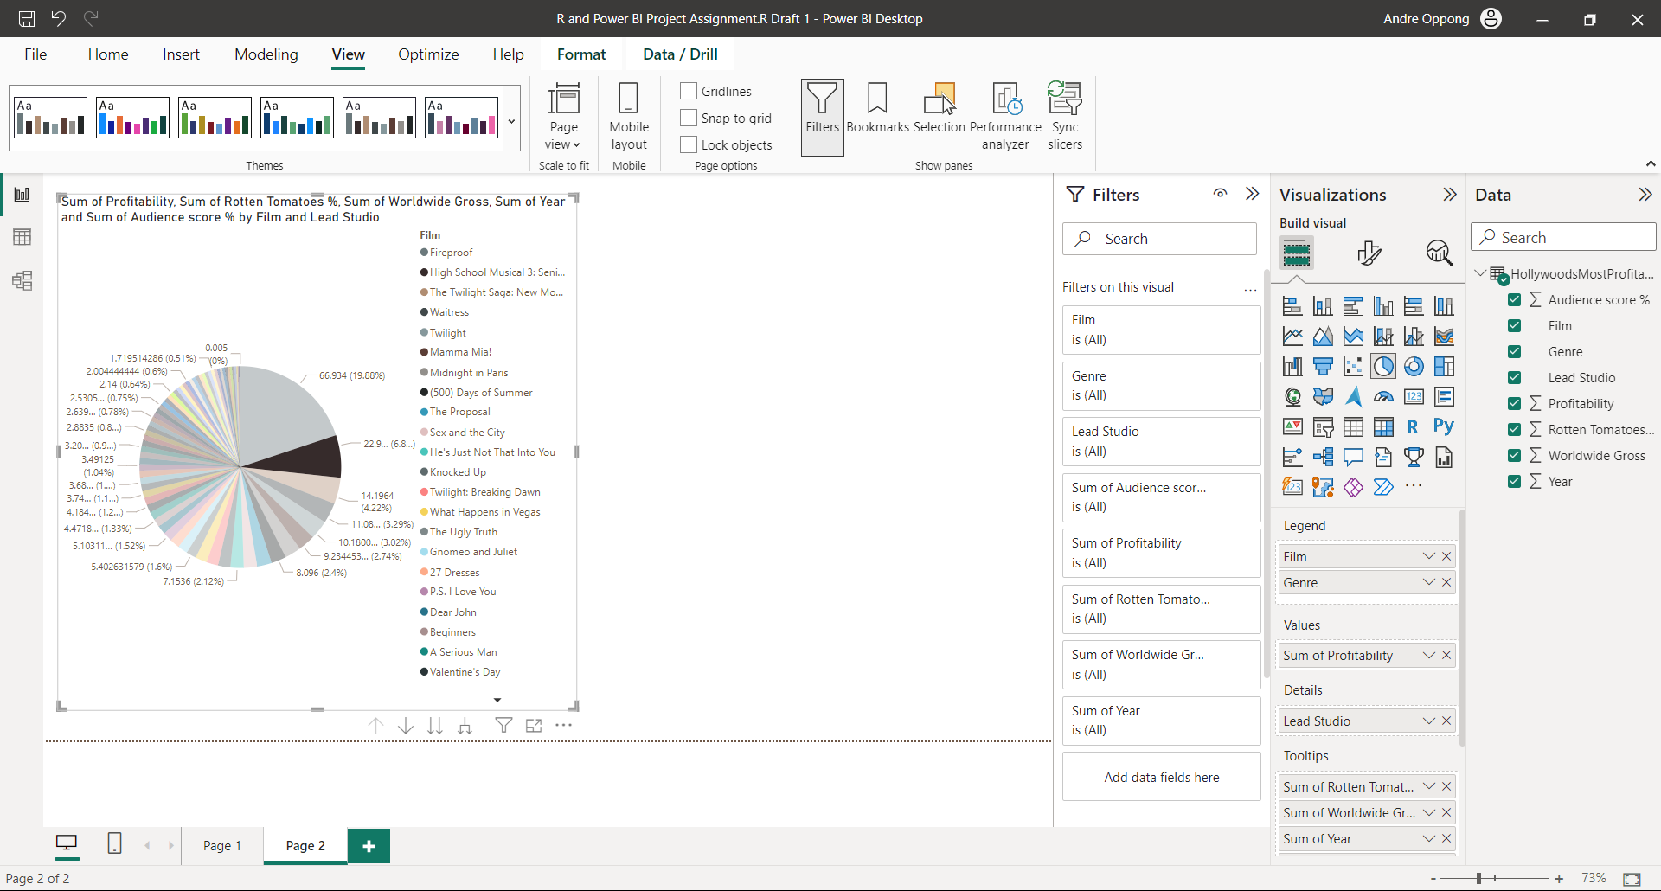

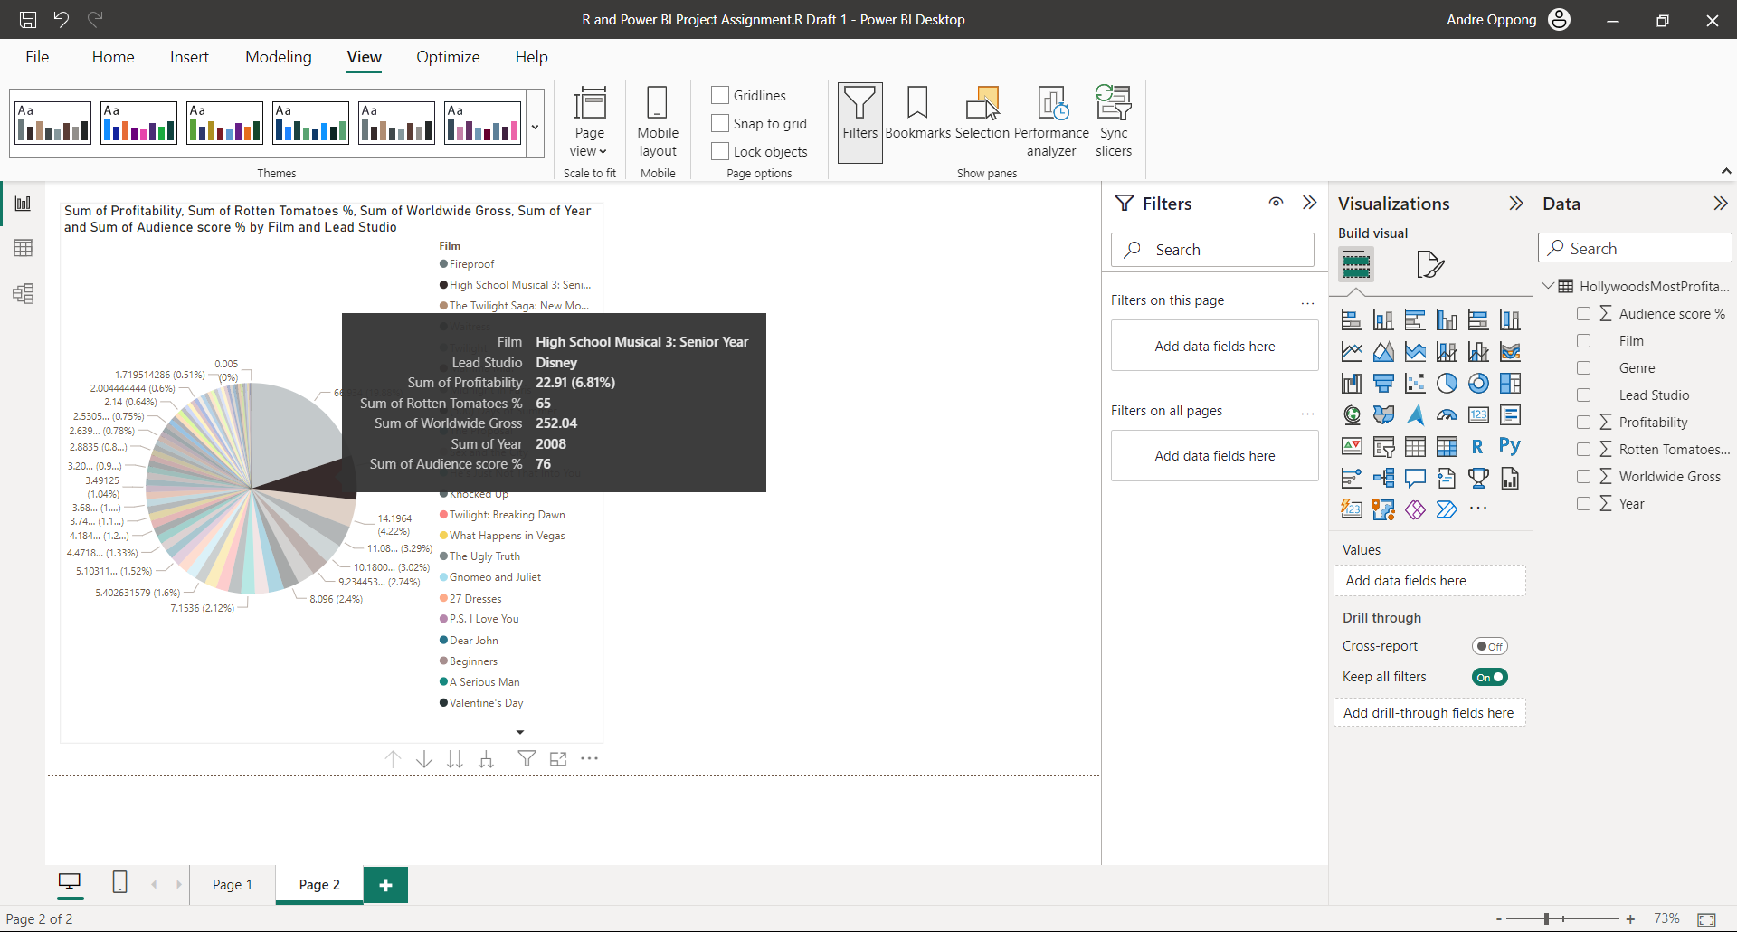I used brown to colour and create my own Pie Chart on Films.

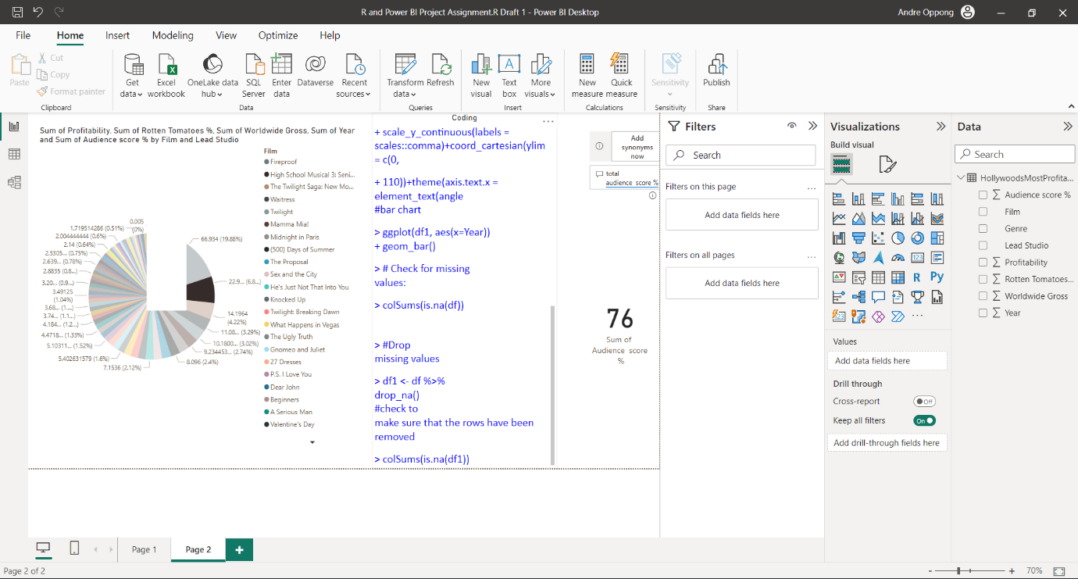The Pie Chart showed, 76% of people watched the High School Musical 3: Senior Year film.

I clicked on the R Scripts button and pasted all the codes from the Word Document to R Scripts section in Power BI.

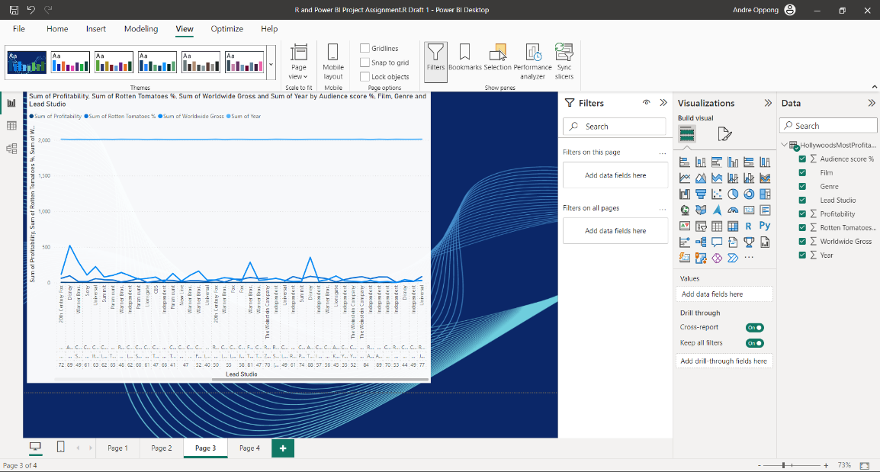

I chose the light blue for my background and dashboard, because it makes it easier for me to identify specific information on the Line Chart.

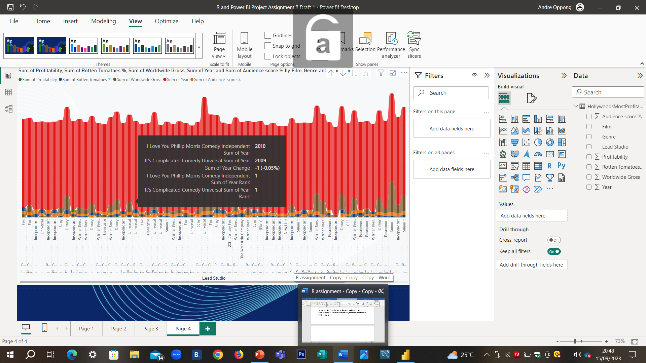

I have learnt how to create a Ribbon Chart for my own dashboard. The information on the Ribbon Chart showed, there was (-0.05% for the Year change.

I used a mixture of bright colours to identify key information on the Ribbon Chart and dashboards.

In addition, the results showed up on the Ribbon Chart for each films and genre- “I love you Philip Morris Comedy Independent 2010” and “it’s Complicated Comedy Universal”.

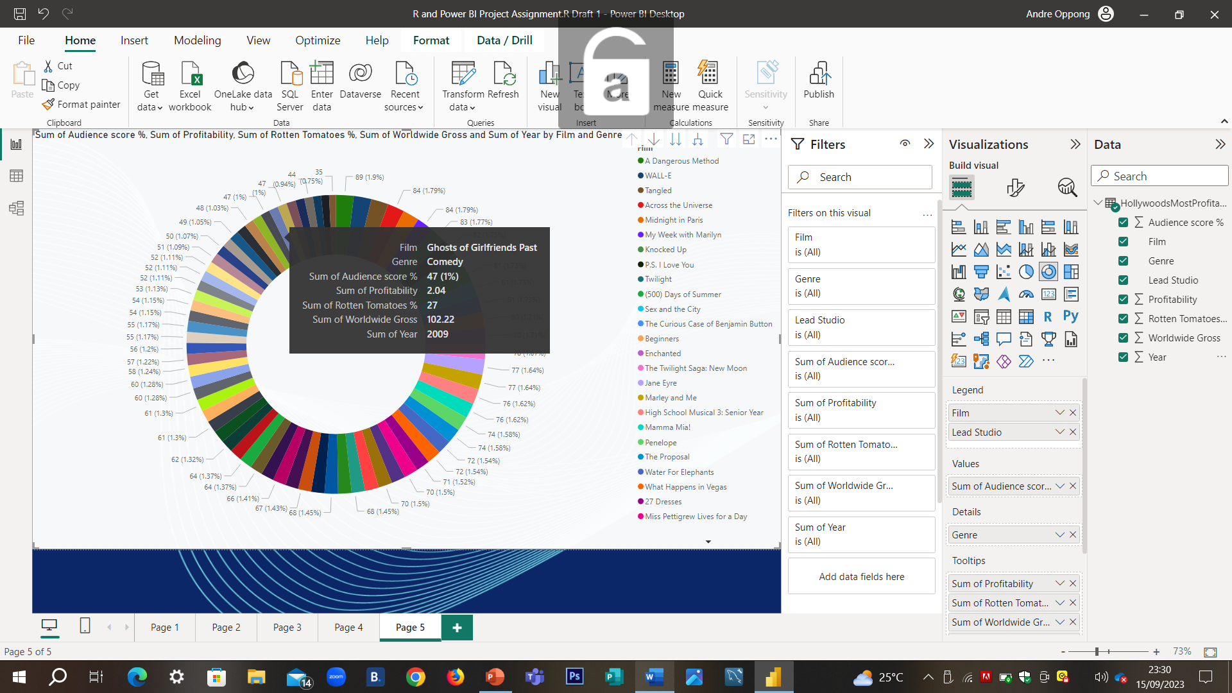

I used different varieties of colours to create a whole Doughnut Chart.

On the Doughnut chart, I can see the statistics on Sum of Rotten Tomatoes (27%) and sum of audience (47%).

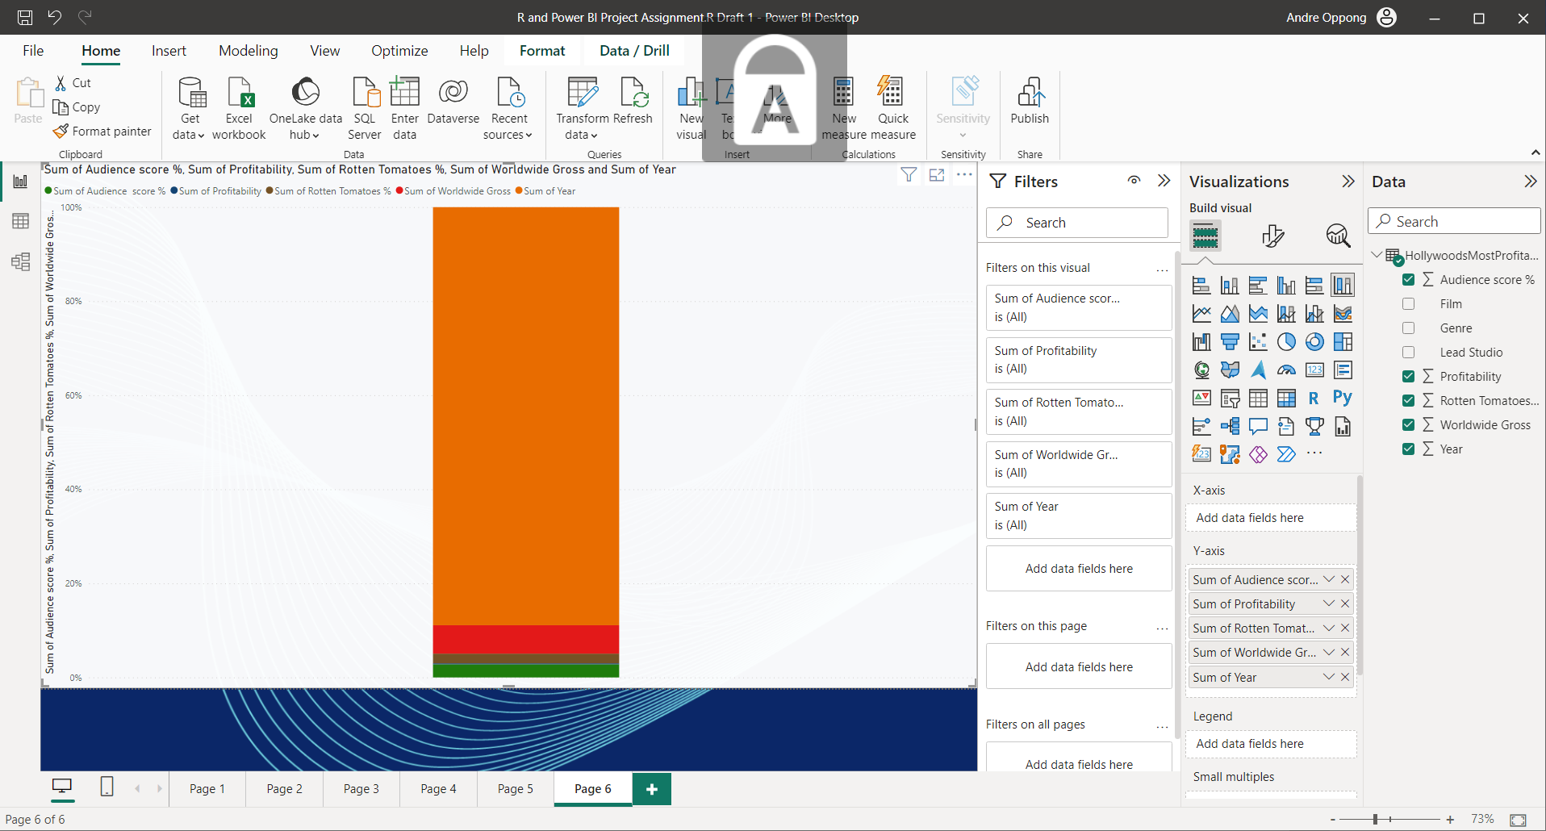

This is my final chart, I have created for the Sum of Audience Score, Sum of Profitability, Sum of Rotten Tomatoes and Sum of Worldwide Gross and Sum of Year.

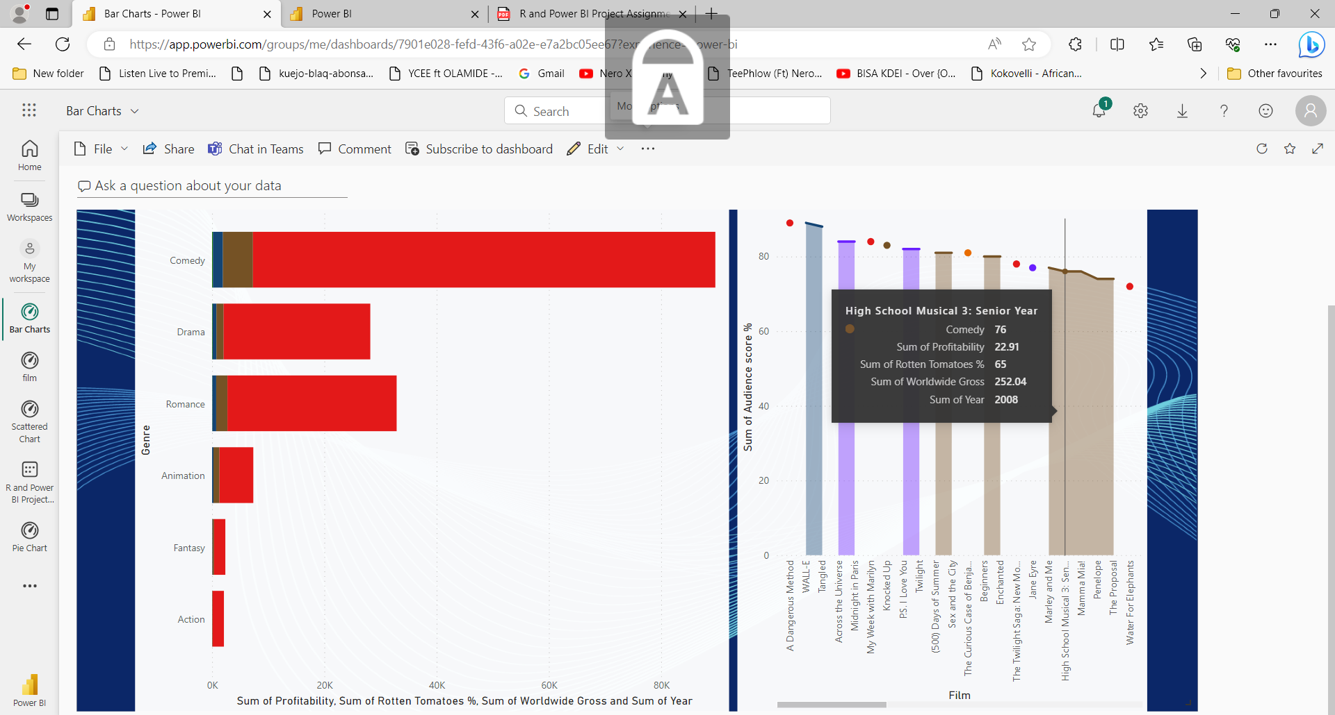

I designed my Bar Chart on films.